Proposed Programme Schedule

International Programme on
PROJECT MANAGEMENT
TRAINING & CERTIFICATION (PMTC)
(04th Nov to 16th Dec 2019)

THE NATIONAL INSTITUTE FOR ENTREPRENEURSHIP AND SMALL BUSINESS DEVELOPMENT (NIESBUD)
Ministry of Skill Development and Entrepreneurship, Govt. Of India
A-23, Sector-62, Institutional Area, Noida - 201309, UP, India
www.niesbud.nic.in

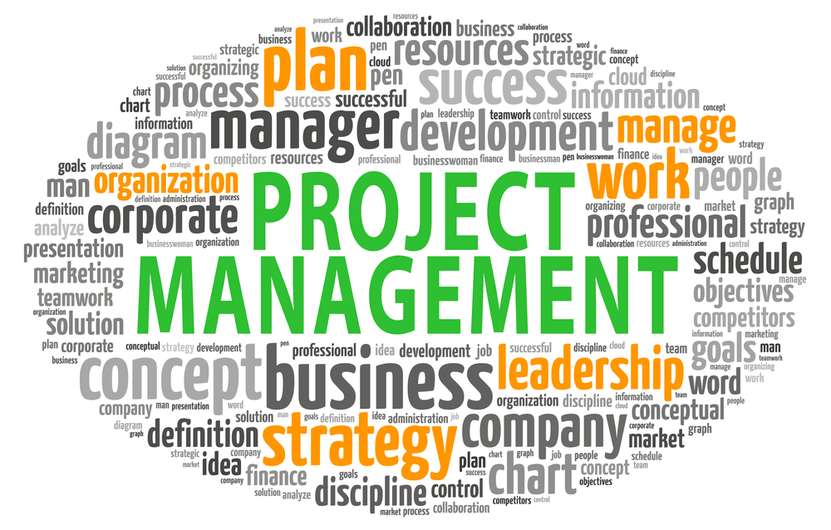

International Programme on
PROJECT MANAGEMENT
TRAINING & CERTIFICATION (PMTC)
(04th Nov to 16th Dec 2019)

Introduction
People have been undertaking projects since the earliest days of organized human activity and continue to do so to achieve something unique. Project management, the practice of initiating, planning, executing, controlling, and closing the work of a team to achieve specific goals, meet and exceed the expectations of the stakeholders is the dream and quest of every project manager .However, this is a challenging responsibility, the primary challenge being to achieve all of the project goals within the given constraints, multiplied manifold by the disruptions, in this Volatile, Uncertain Complex and Ambiguous world.

In order to strive and thrive in this environment and deliver projects with a standard of excellence requires the development of professionals who can practice the art of understanding the dynamics of project management, organize & implement the projects successfully.

Training interventions help in acquiring the latest skills and knowledge in the field of project management. Keeping the need in view, NIESBUD has designed six-weeks International Programme on Project Management Training & Certification (PMTC).

PROGRAMME OBJECTIVES

The programme aims at enhancing overall project management knowledge and skills of participants by enabling them:
- To identify the resources required as inputs of the project;
- To understand the project cycle and examine the various issues related to
project management;
- To develop the capability to plan, implement, monitor and evaluate the
Project;
- To enhance ability to appraise the project from different perspectives;
- To assist in enhancing confidence in the project management and
business competitiveness.

DURATION
Six Week

COURSE CONTENT
The course content has been designed in a modular form comprising of the following modules: -
BASICS OF PROJECT MANAGEMENT

- Concept of project & its classification
- Characteristics of project
- Introduction to project management
- Project life cycle

PROJECT IDENTIFICATION AND APPRAISAL/FEASIBILITY

- Generation of Ideas & Project Identification
- Preliminary Screening & SWOT Analysis
- Project Rating and Index
- Market demand analysis
- Project Plan Development
- Feasibility study - Political, Economic, Sociological, Technical, Legal, Environmental (PESTLE) analysis
- Stakeholders’ expectations analysis
- Financial viability etc.
- Investment Evaluation (Payback period, NPV, IRR, Profitability Index etc.)

PROJECT PLANNING
BROAD PLANNING:
- Duration of project and resources available
- Time plan – key mile stones
- Introduction to cost budget
- Period-wise progress plan vs. expenditure plan

SCOPE MANAGEMENT:
- Project scope management process
- Product breakdown structure
- Work breakdown structure
- Statement of Work (SOW)
- Scope change control

TIME MANAGEMENT AND COST MANAGEMENT:
- Estimation techniques
- Cost baseline
- Earned value management system

QUALITY MANAGEMENT:
- Concept of quality
- Quality planning, assurance and control
- Quality tools
- Total quality management
- ISO 90001 for quality

ORGANIZATION STRUCTION:
- Functional, matrix, project organizations
- Roles and responsibilities
- Responsibility assignment matrix
- Project review teams

PROJECT GOVERNANCE:
- Defining integrity policy
- Code of conduct of all participants
- Zero tolerance areas

COMMUNICATION MANAGEMENT:
- Communication model
- Types of communication
- Communication plan
- Barriers to communication

PROJECT IMPLEMENTATION

DEVELOPING & MANAGING TEAMS:
- Team development stages
- Alignment of team members
- Synergy approach to team working

BEHAVIOURAL SKILLS:
- Leadership, morale building
- Motivating team members
- Conflict management

PROCUREMENT & CONTRACTS:
- Types of contracts
- Law of contracts
- Negotiation techniques & skills
- Supply chain management

CHANGE CONTROL:
- Identifying and approval of changes
- Change control process
- Change log

HEALTH, SAFETY, ENVIRONMENT PLANS:
- ISO 14001 for environment
- OHSAS 18001 for health and safety

DOCUMENTATION:
- Technical documentation
- Performance reports
- Monitoring reports
- Quality control records

PROJECT MONITORING & CONTROL

INFORMATION & REPORTS:
- Planning documentation & reports
- Managing the information

PROJECT MONITORING PROCESS:
- Management information system for periodic key parameter reporting
- Review meetings (agenda and periodicity)

TIME & COST OVER-RUNS:
- Identifying delays and anticipated delays
- Deciding on corrective steps and integrating into plan
- Cost over-runs foresee and apply corrective action well in time

DESIGN THINKING AS TOOL FOR PROBLEM SOLVING:
- Tools and techniques
- Define the problem
- Determine the causes
- Generate ideas
- Select the best solution
- Take action

RISK AND OPPORTUNITY CONCEPTS:
- Risk identification
- Qualitative & quantitative risk assessment
- Risk response strategies
- Risk tools

PROJECT CLOSING
INTEGRATION OF PROJECT:
- Coordinating subprojects for alignment
- Achieving and parameters (technical)

DELIVER & CLOSING OF PROJECT:
- Formal check and verification by customer
- Handling over documents to be well prepared and signed by concerned parties
PENALTY CLAUSES:

Study Visit
- Visit to various industrial/business centres to learn about Project management techniques/practices
- Visit to various colleges/Universities for interaction on developments Project management.

Preparation of Study Visit Report and Back Home Action Plan
- Reports on organizations visit
- Back Home Action Plan

COURSE METHODOLOGY

The course is geared towards adult learning and uses participatory approaches as much as possible. A variety of methodologies will be used, including lecture/presentation, discussions, simulation exercises, debates, group work, video discussions, question and answers, demonstrations, practical sessions, small and large group exercises, role plays and field trips.

FACILITIES

LIBRARY FACILITIES
NIESBUD has a highly specialized library with an excellent collection of books and periodicals, a number of reports and other unpublished material related to its fields of interest. The library is open from 0930 hrs. to 1800 hrs. daily, except on Saturday/Sunday. Books may be borrowed (not more than two at a time) from 0930 hrs. to 1800 hrs. Monday to Friday.

