Proposal for International Training Programme on Solar Energy Technologies and Applications under Indian Technical and Economic Co-operation (ITEC) for the FY 2020-21
Organized by
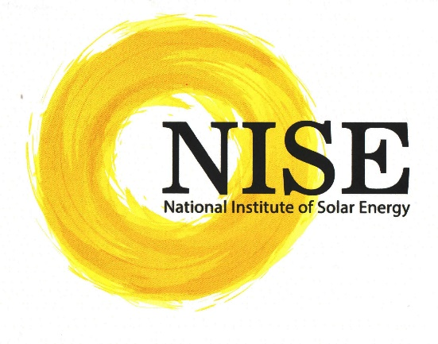
National Institute of Solar Energy
An Autonomous Institute of
Ministry of New and Renewable Energy,
Govt. of India,
www.nise.res.in
December, 2019

Contact:

Dr. Chandan Banerjee, (DDG)
National Institute of Solar Energy,
Gurgaon, Haryana- 122003
Phone: +91 124 2853001
Mobile No.: +91 9205504510
Email: international.nise@gmail.com
www.nise.res.in
- Objective: Advanced skill development for the International participants about the current solar technologies.

- Title: “International Training Programme on Solar Energy Technologies and Applications under Indian Technical and Economic Co-operation (ITEC)”

- About Program:
The technical training program can be organized for the officials under Indian Technical and Economic Co-operation (ITEC) from different countries during the FY 2020-21.

To develop the solar technology field in these countries, the technical training can be provided to the officials for enhancement of the knowledge in the field of Solar Technologies. NISE has been conducting international training programs on various field of renewable energy. The knowledge can be utilized by the participants to further develop an understanding of the respective field and its implementation to mature the Solar Technologies.

The training program are to be conducted for the officials in five batches consisting of 35 participants in each batch. Hence the training program can be organized for total number of 175 slots during year 2020-21.

- Program Outcome
- The program shall enhance the technical capabilities of the participants
- The program shall impart knowledge of the Global trends on Solar Technology by exchange of information
- The program shall help to set up “Standards” on Solar Photovoltaic, Solar Thermal and Solar Lighting Systems
- The participant shall be able to train their respective countries man power in the field of solar technology

- Participant Profile
The program is meant to develop the technical skills in selection, installation, operation & maintenance of solar technologies. The qualification of the participants should be:
- Post graduate in science (physics) or Graduate in engineering/technology (electrical, electronic or mechanical)
- Knowledge in English
- Candidate having experience in the field of renewable energy is more desirable or those intending to join this sector.
- Middle to higher level government / Semi government official are the target participants for the programme.
- Private companies can also join the course if recommended by National Focal points or Indian Missions abroad.

- Schedule and Duration:

Duration of program will be about 3 weeks. Following are the schedule drawn for training:

Batch | Start Dates | End Dates
ITEC - Batch 1 | 17th August , 2020 (Mon) | 4th September, 2020 (Fri)
ITEC - Batch 2 | 5th October,2020 (Mon) | 23rd October, 2020 (Fri)
ITEC - Batch 3 | 16th November, 2020 (Mon) | 4th December, 2020 (Fri)
ITEC – Batch 4 | 11th January, 2021 (Mon) | 29th January, 2021 (Fri)
ITEC Batch 5 | 8th February, 2021 (Mon) | 26th February, 2021 (Fri)
- Past Experience:
NISE has been conducting National and International Training Programs on various aspects of Solar Energy for different target groups for the past 15 years. In the area of international training, so far NISE has organised many international training programmes and trained participants from Africa, Asia including counties Ethiopia, Sudan, Tanzania, Nigeria, Mauritius, Vietnam, Afghanistan, Mongolia and Nepal as a part of its ITEC and other international programmes sponsored by Ministry of External Affairs (MEA) and Ministry of New & Renewable Energy (MNRE). These programmes are conducted to the satisfaction of participants and their countries on various areas of Renewable Energy.

- Air Travel:

Air Travel for candidates has been budgeted as air tickets would be provided by MEA to participating candidates.

- Tentative Course Details & Contents:
Days | Particulars
Day 1 | - Introductory Session on Solar PV and Thermal  - Solar Energy Fundamentals
Day 2 | - Testing standards of SPV systems  - Solar Photovoltaic Cell and Technologies  - SPV systems and Components
Day 3 | - Basics of Solar Thermal  - Solar Thermal and Biomass  - Solar Thermal Power Generation
Day 4 | - Inverters & Charge Controller  - Batteries for SPV applications
Day 5 | Visit to 1 MW power plant at Gugaon and / or visit to Central Electronic Limited (CEL), a Solar manufacturing unit, in Ghaziabad
Day 6 | Visit to Solar Installation Agra (Taj Mahal)
Day 7 | Rest
Day 8 | - India Experience on Roof Top and 1 MW Solar  - Performance and Reliability of SPV modules in out-door
Day 9 | - SPV system design  - PV Simulation tools like PVSOL/PV syst
Day 10 | - Installation, Sequence, Testing & Commissioning of PV power plant  - Lab Visit
Day 11 | - Hybrid Solar biomass Power plant in poly-generation process for combined power cooling and process heat  - Various Policies
Day 12 | Visit to Solar Projects in Delhi
Day 13-14 | Important Solar Project Site Visits (One night stay during the outstation study tour)
Day 15-16 | Internal Assessment & Country Presentation
Day 17-18 | - Administrative Formalities  - Valedictory Session
Day 19 | - Country Papers
- Faculty:
- Senior scientists from NISE having 15-20 years of experience in Solar PV and Solar Thermal technologies
- External speakers from ministries will be providing lectures on case studies, policies and programs of India’s National Solar Mission
- External faculties from Industries, Institutions, Multi-lateral agencies will also be called

- Contact Information:
- Dr. Arun K Tripathi, Director General,
Email : aktripathi@nic.in , dgnise.mnre@gmail.com
- Dr. Chandan Banerjee, Dy. Director General,
Email: chandanbanerjee74@gmail.com
- Ms. Pooja Sharma, Consultant,
Email: international.nise@gmail.com, pjharnal@gmail.com

A Brief Details of Training Institute in India
National Institute of Solar Energy (NISE)
National Institute of Solar Energy (NISE), an autonomous centre of excellence of Ministry of New and Renewable Energy, Government of India, is conducting national skill development programs to meet the needs and upgrade the technical expertise of solar professionals.

NISE is engaged in Solar PV/Thermal, R&D, Testing, Demonstration Projects, Skill Development, Consultancy, innovation and Incubation etc. NISE is offering various consultancy services to various Central Ministries, Armed Forces, PSU’s and corporates on Solar Power Projects, Rural Energy, Cold Storages, Food processing industries etc.

Skill Development Division has been conducting several training programs for International participants, Industrial participants and Entrepreneurs etc.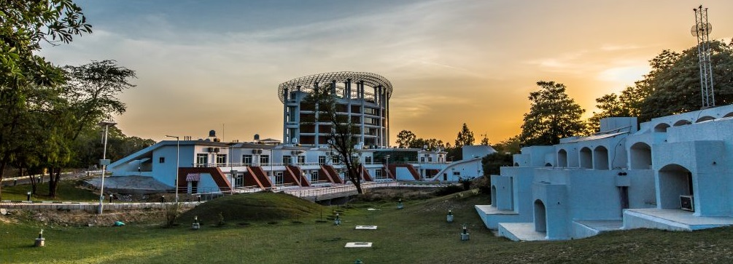
The institute has modern class rooms which are equipped with high quality systems for conducting lectures of various training programs.
This institute is setting up standards on Solar Photovoltaics, Thermal and solar PV lighting systems in India as well as for some other Asian countries. The various divisions of NISE are headed by senior scientists and supported by about fifty young scientists.
Different division at NISE:
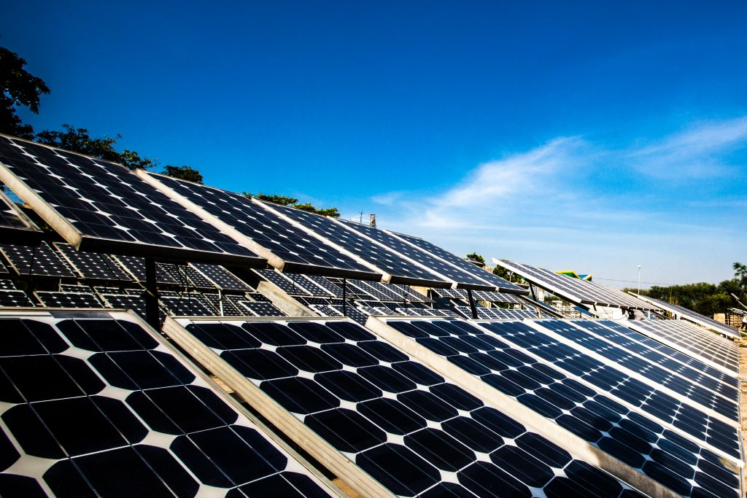

- Photovoltaic Module Testing Facility: This facility is National accreditation board for testing & calibration laboratories (NABL) accredited laboratory as per standard IS 17025:2005. The laboratory is well-equipped to conduct the tests of PV modules as per the Indian (BIS) and International (IEC/UL/ASTM) Standards. The testing standards like: IEC 61215, IEC 61646, IEC 61730 are being conducted.
- Solar Cell Testing Facility: For testing and evaluation of performance of Solar Cells as per IEC 60904-1:2006/IS 12762 (Part1). The cell were tested under standard test conditions (1000 W/m², cell temperature 25 ºC, AM 1.5). The spectrum of the source qualify standards like IEC 60904-9; 2007 Edition or ASTM E 927-05. The current- voltage (I-V curves) measurements, both dark and light conditions of solar cells can be studied at different intensities and temperatures.
- SPV Outdoor Facility: Outdoor test bed facility of NISE is the unique facility for long term outdoor performance testing of PV modules in the India. Test bed consists all variety SPV technologies modules of the world. The test bed has PV modules since 1992 to till date, i.e. for last 22 years. The testing like Degradation analysis, Energy Yield (Yi) and performance Ratio (PR) and Performance modelling as per IEC 61853, in terms of Energy rating can be done along with Reliability and safety analysis in terms of Risk Priority Number (RPN).
- SPV Lighting Test Facility: NISE has advance SPV systems & Lighting Lab is engaged in the performance, reliability & validation testing of Solar Lighting systems & other PV based systems i.e. road stud, garden light, task light, study lamp, torch, solar e-rickshaw & air conditioner as per the National & International standard.The major Solar PV lighting system includes portable solar lantern, home and street lighting systems etc. The technical testing specifications was defined by MNRE for lanterns, home lighting and street lighting system etc., and revision and design guidelines for systems was made by NISE. These guidelines are further adopted by the manufacturing industries and the user agencies in their programmes. The testing of systems are performed as per BIS ET-28 and IEC 62257-9-5 standards.
- Inverter Testing Facility: For testing and evaluation of Solar Inverters/ Power Conditioning Units (PCU) of capacity ranging from 100 VA to 50 KVA. All types of inverters like hybrid, standalone and grid-tied and PCU can be tested with well-equipped instruments. The reports are generated as per IEC 61683, IEC 62116 and UL 1741 standard. The lab is also the suggesting various converters for SPV based small scale house hold as well as street lighting systems.
- SPV Battery Testing Facility: This lab equipped with advance equipment to carry out testing and certification of major secondary battery storage technologies such as lead-acid, NiMH, NiCad, NaS and Li-ion (all salts). Manufacturers are also advised on best practices to produce long lasting and efficient products. For maintaining standard testing conditions the lab is equipped with a climatic chamber having a wide range of operating temperature. The lab can accommodate samples up to a maximum of 3000Ah. The testing of various kind of batteries were performed as per standards like IS13369, IS15549, IS1651 and IEC 61427. The battery lab is also engaged in various projects such as Performance analysis of various secondary battery technologies and Degradation analysis of batteries under field conditions in SPV applications.
- SPV Water Pumping Testing Facility: For testing of different capacity pumps ranging from 0.5 HP to 5 HP with array capacity of 200 Wp to 5 kWp. Both surface and submersible, AC/DC Motor driven pumps can be tested as per MNRE specifications or user specifications by taking reference from IEC 62253 and IEC 61702 standards.
- Solar Thermal Facility: Institute has setup state-of-the-art Solar Thermal Technologies for different end use applications such as power generation, air-conditioning, cold storage, process heat, desalination, testing of solar thermal technologies, solar water heating system, cooker etc. A grid-interactive solar thermal power plant, with a capacity of 1 MW at Direct Normal Irradiance (DNI) of 600 W/m², has been designed developed and commissioned at NISE, in collaboration with IIT Bombay and other consortium partner. This division is also developing solar cooling and 50 kW solar biomass hybrid cold storage cum power generation system for rural electrification.
- Hydrogen Generation & Dispensing Facility: NISE boasts of housing India’s first Solar based Hydrogen Generation Storage & Dispensing Station powered by 120kWp Roof top SPV System. The Hydrogen Division of NISE at present has a solar based Hydrogen Generating Facility. We have a 5Nm3/hr capacity of Electrolyser for our Hydrogen Dispensing station. The Alkaline based Electrolyser uses the Ground water and with Electricity generated from Solar Power plant we produce Hydrogen of 99.9999% purity [Fuel cell grade]. NISE boasts of the state of the art infrastructure for the Hydrogen Facility. This is the India’s first Solar Based Hydrogen Generating facility, unlike other Hydrogen stations worldwide Hydrogen station is directly coupled to the Solar Power plant. As of now only very few Hydrogen station operate in Directly Coupled mode.
- Fuel Cells Testing Laboratory at NISE: NISE is establishing a Fuel Cell Testing Laboratory for Research &Development, testing of various types of Fuel Cells, monitoring & evaluation to study the performance of the Fuel Cell Components & systems at different capacities, comparison of different kind of fuel cells in India and their techno-economic viability, development of test protocols for various type of Fuel Cells and development of standards for Indian conditions. The Centre will be a full-fledged Research and Technology facility with wide ranging laboratory and workshop facilities for research and prototype testing.
- 500 k Wp Multi technology Power Plant: NISE has embarked upon a major projects of setting up in its campus a 500 k Wp, multi-technology, solar photovoltaic power plant. It provides uninterrupted power supply in the campus on 24*7 basis and also serves a test bid for multiple solar PV technologies. The design of the plant is such that of the total power generated, 20 k Wp supply is connected to the battry bank and 300 k Wp is fed to the grid. The 500 k Wp power plant having five different PV technologies (mc-Si, HIT, SunPower, CIGS, CdTe), each having a capacity of 100 k Wp.
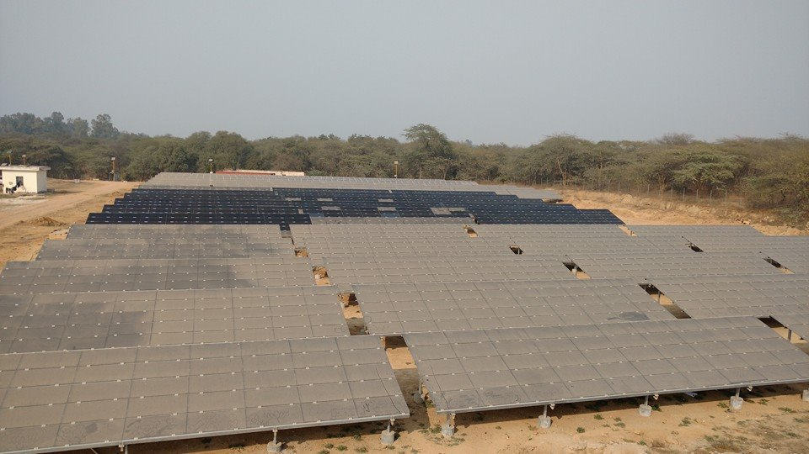
- Skill Development Laboratory: This facility consists of two types of laboratory to conduct the hands-on training for the development of respective skills.
  - Solar PV Electronics:
The main objective purpose of the these experiments is to determine the electrical parameters such as I-V and P-V charactertics of solar PV modules at various operating conditions, understanding the series/parallel connection of solar PV modules while evaluating its output voltage and current. It allows the students to learn the use of measuring equipments required for solar PV systems, investigation on output of solar PV depending upon the effect of partial shading, shading analysis conducted on the proposed site, performance evaluation of inverter, charge controllers and battery, realization of the power flow in the solar PV grid connected and standalone system, use of solar PV software for approximating the yield of PV system, study of DC home lightning system, the balance of plant components, protection against various faults such as surge protection device, fuse, circuit breakers , lightning arrestors, cable sizing and operation and maintenance guidelines followed for a solar PV system.
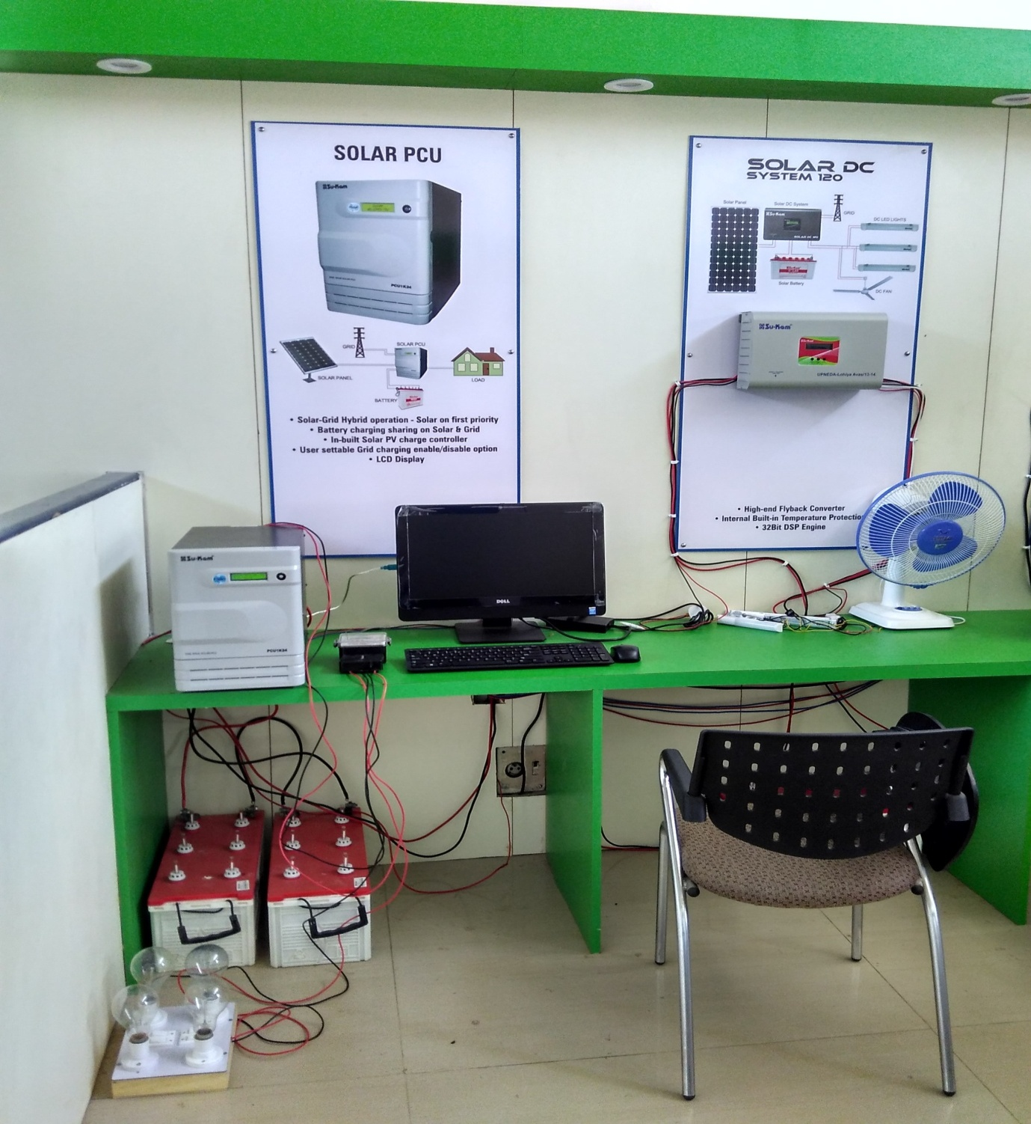 | 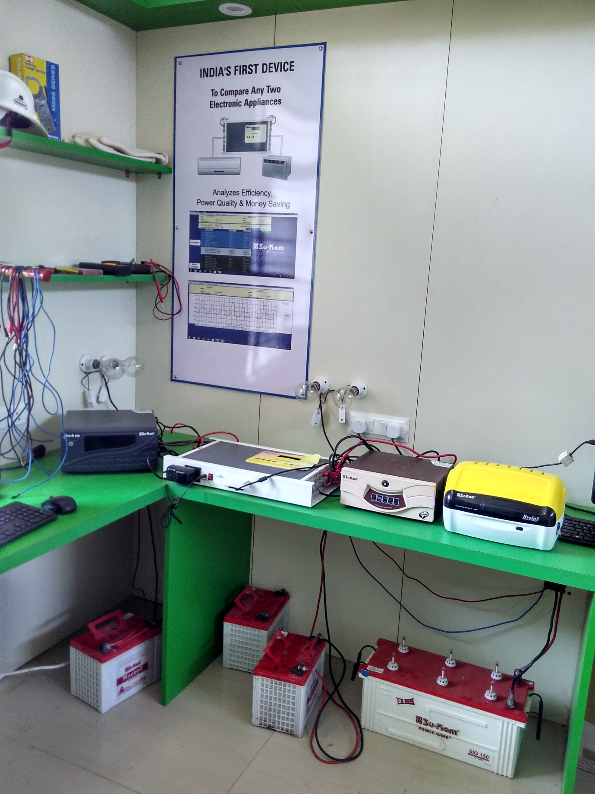 | 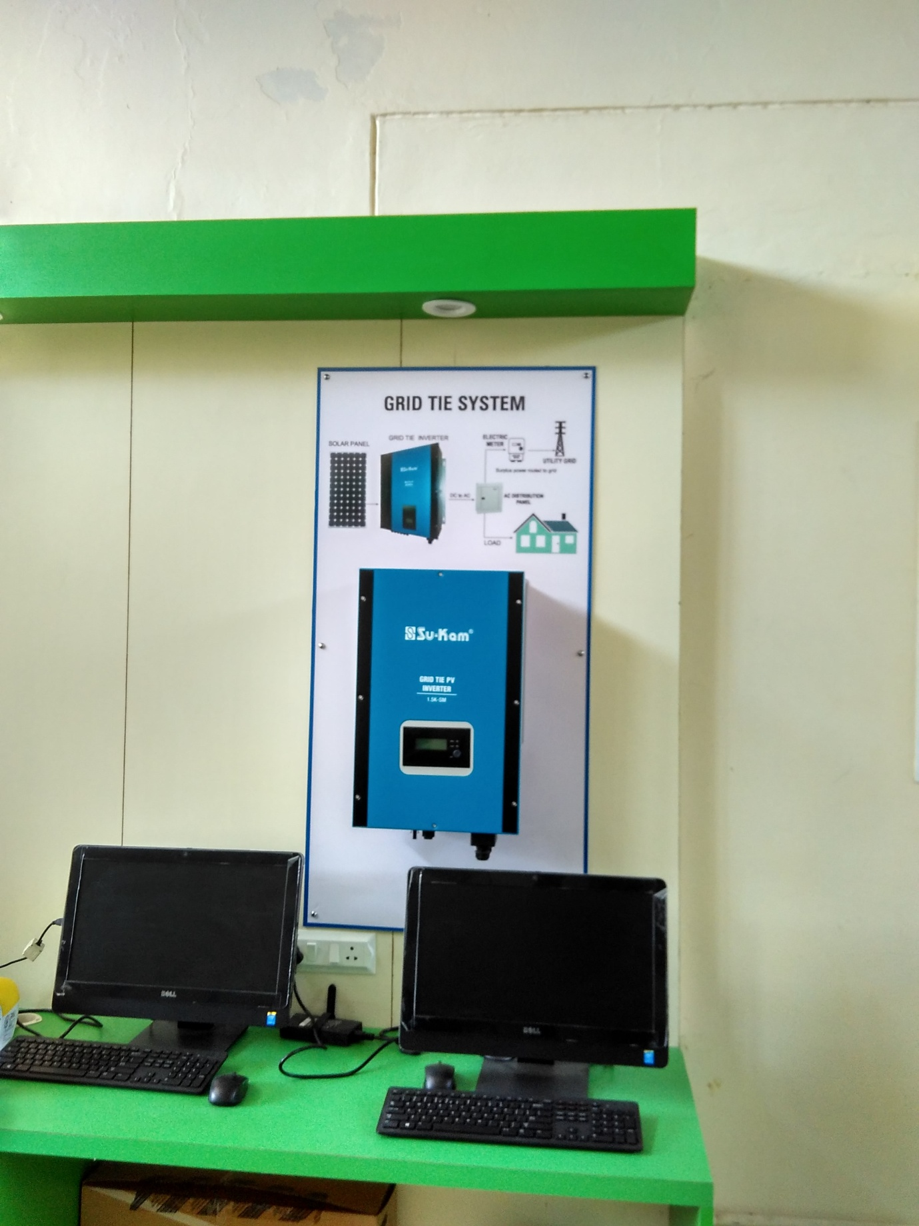
  - Renewable Energy: The concept of implementing an optimised renewable energy skill development laboratory is to provide an interactive training for PV, thermal and wind systems where the concepts are clear and one has the knowledge to work on the real time system installation, operation and maintenance. These training laboratory gives an in depth analysis and create expert individuals for the deployment of renewable energy resources. Thus, the emerging necessities for providing necessary facilities for renewable energy sector are easily available.
 | 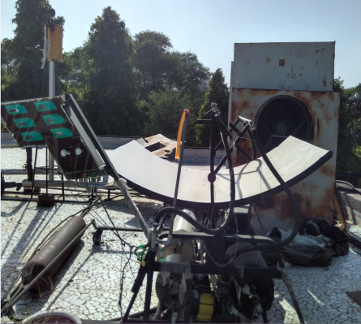 | 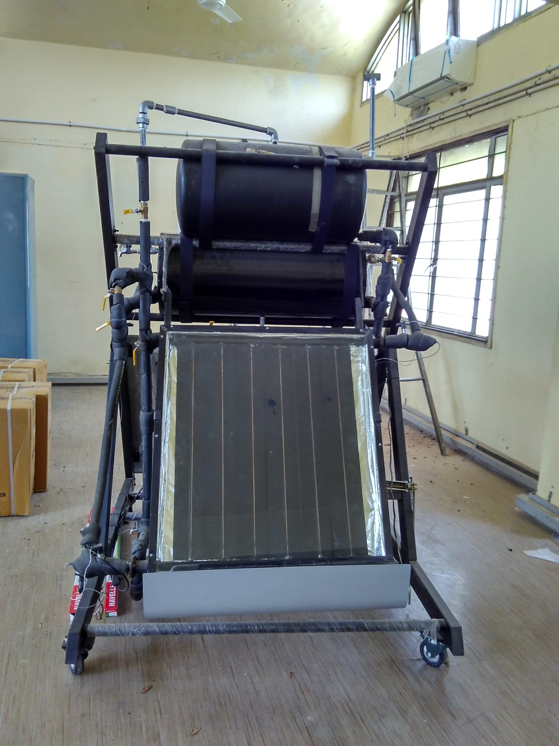

About Place: About NISE Campus:

The NISE campus for its R&D activities is located at the 19th milestone on the Gurgaon-Faridabad road which is about 25 km south of main office of the Ministry. The surrounding area is predominantly agricultural and beautiful green or yellow fields can be seen around the Campus depending upon the season. Covering an area of about 81 hectares, the campus receives abundant sunshine for which is suitable for doing solar energy experiments. The buildings of the Centre have been constructed using solar passive techniques to achieve energy efficiency and environmental friendliness. The campus offers the following facilities:

- Auditorium: An air conditioned hall in theatrical style which can accommodate 125 persons. It is provided with a dais and a public address system, multimedia projection system with good acoustics. Registration desk and arrangements for tea & snacks are available in the adjacent lobby.

- Library: NISE has a fully furnished central library consisting of about 1500 latest books on various aspects of renewable energy technologies. NISE subscribes to 15 scientific journals.

- Guest House: To accommodate the training officials and the guest, the institute has its own guest houses. The new guest house is equipped with all the facilities at par with international standards. There are 30 rooms in the new guest house. The old guest house consists of six well furnished rooms of which four rooms are air conditioned.

- Seminar Halls and Conference Rooms: There are numerous seminar halls and conference room facilities available in the old and the new buildings which can be extended for hosting functions with large gathering.

- GYM & SPORTS Facilities: Most Morden gym and other sports and games facilities are also available in the NISE Campus.

- Yoga Centre: Good yoga centre with qualified instructor are available in the NISE Campus.

National Institute of Solar Energy,
Gwal Pahari, Gurgaon, Haryana- 122003
Phone: +91 124 285 3039
Mobile No. +91 9818156427
Email: international.nise@gmail.com
Webpage: www.nise.res.in

