Proposed ITEC Course 2020-21

Healthcare at Scale : Inspiration from Traditional
AYUSH Medicine Systems of India

Dates : November 9-22, 2020

Venue : IIT Delhi Sonipat Campus

Coordinator : Prof V M Chariar, IIT Delhi

PART A | Synopsis, Aim, Objectives, Course Contents,  Outcomes, Audience, Eligibility
PART B | Indian Success Stories, Govt & Pvt Sector Engagement, Sectoral Focus, Rationale
PART C | Co-ordinator Contact Details & CV
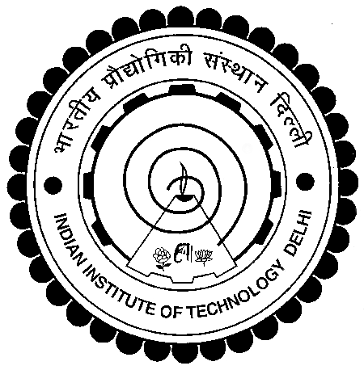

Proposed ITEC Course 2020-21

Healthcare at Scale : Inspiration from Traditional
AYUSH Medicine Systems of India

PART A
(Synopsis, Aim, Objectives, Contents, Outcomes, Audience, Eligibility)

a. Course Synopsis : This interdisciplinary learning experience “Healthcare at Scale : Inspiration from Traditional AYUSH Medicinal Systems of India” is for I-TEC participants who are keen to learn about the role of Traditional Medicine Systems to provide culturally appropriate, cost-effective healthcare solutions at scale in society. This course would enable participants to powerfully apply their domain knowledge in an interdisciplinary setting. Participants would learn how Grassroot Organisations in India have collaborated and co-created and worked with various organs of Govt of India’s AYUSH Ecosystem to provide healthcare solutions to communities at remote locations where modern healthcare delivery can face last mile issues. The short term course is designed for policy makers, government officials, elected representatives, prospective entrepreneurs, corporate managers, academicians and researchers. The Faculty Members and Resource Persons associated with delivery of this short-term course have rich experience in traditional medicine systems, grassroots research and community knowledge. The course mentors would be happy to engage and support the participants to carry forward the course outcomes into tangible interventions - both impact interventions and disruptive products and services – that add value to society at large.

b. Aims of the Course : The single most important aim of the course “Healthcare at Scale : Inspiration from Traditional AYUSH Medicinal Systems of India” is to empower government officials, industry participants, entrepreneurs, academicians and researchers in developing nations across the world by exposing them to the nexus of the talent pool of Innovators in India and to the Indian Innovation Ecosystem which has resulted in entrepreneurs creating wealth, improving quality of life and multiplying livelihood opportunities in the rural economy.

c. Course Objectives / Learning Objectives :
The course objectives are as follows :
- To familiarize participants with the vast reservoir of knowledge available in traditional medicinal systems of AYUSH in India which have universal relevance
- To appreciate the possibilities of collaborating with networks of Traditional Health Practitioners in India and develop innovative solutions for one’s own context
- To develop a strategy of grassroots healthcare that recognises role of integrated approach combining modern approaches and traditional approaches to improve health outcomes of citizens at scale

d. Course Contents

Module No. | Contents | No of Hrs
1 | Course Introduction & Keynote Speaker | 6
2 | Identifying Sources of Traditional Knowledge | 6
3 | Strategies for Validation of ITK | 6
4 | Practitioner Perspectives : Ayurveda for Universal Health | 6
5 | Practitioner Perspectives : Yoga for Wellbeing | 6
6 | Practitioner Perspectives : Unani & Siddha Folk Remedies | 6
7 | Practitioner Perspectives : Homeopathy for Childcare | 6
8 | Blending Traditional & Modern Healthcare Approaches | 6
9 | Strengthening Grassroots Public Health System | 6
10 | Local Cultural Visit | 6
11 | Local Cultural Visit | 6
12 | Industry Visit – AYUSH Healthcare Products & Services | 6
13 | One Day Roundtable with Govt Officials & Corporate Bodies | 6
14 | Keynote Speaker & Course Valedictory | 6
 | Total Contact Hours | 84

e. Expected Course Outcomes of the Course :
On successful completion of the course “Healthcare at Scale : Inspiration from Traditional AYUSH Medicinal Systems of India”, the participants will be able to
- Identify sources of traditional medicinal knowledge in their own culture and region
- Chart a Road Map to enable development of local, regional, and national health plans which utilise Traditional Medicinal Knowledge at scale
- Strengthen the grassroots Public Health System by utilising scientific, culturally appropriate and cost-effective healthcare and nutrition solutions to improve public health outcomes

f. Target Audience : This interdisciplinary short term course is designed for policy makers, government officials who design and implement health programmes, elected representatives, successful as well as aspiring entrepreneurs, herbal and pharma industry associations, corporate managers, academicians and researchers.

g. Eligibility of the participants : The course is transdisciplinary in nature and is open to participants who are keen to support and catalyse or launch healthcare programmes and interventions in their nations with a view to improve health outcomes of the population at scale.

PART B
(Indian Success Stories, Govt & Pvt Sector Engagement, Sectoral Focus, Rationale)

Examples of Indian Success Stories : There are hundreds of interventions and success stories in India where Traditional Medicine Systems have been applied by Traditional Health Practitioners, Civil Society Organisations, Policy Makers and Community Leaders. These interventions have resulted in a more efficient healthcare system and well-being of the rural society. Some organisations that have been seminal work in this space include Baidyanath, Zandu Ayurveda, Dabur India, Patanjali Ayurved, Arya Vaidya Sala Kotakkal, Himalaya Wellness, Hamdard, Dr Vaidya’s, KIVA, &Me and Kapiva.

Exposure to Indian Policy and Governmental Setup : Govt of India has strong Ministry of AYUSH which has been promoting Ayurveda, Yoga, Unani, Siddha and Homeopathy across the country. Through a highly networked organisation structure a plethora of research, scientific validation, product development and service delivery schemes have been creating impact in rural, peri-urban and urban India. The course would expose participants to how the Traditional Medicine Ecosystem has been strengthened from diverse perspectives of knowledge generation, knowledge protection, and knowledge translation. It would also give a glimpse into financial policies which have been instrumental in strengthening and supporting the ecosystem. The I-TEC course will provide avenues opening avenues for mutually beneficial bilateral and multilateral policy level engagement.

Connect to Private Sector & Industry : One-Day Roundtable with Industry bodies such as CII, FICCI, ASSOCHAM, PHD Chambers of Commerce etc. would be organised as part of the course. One-Day Industry Visit will be organised to All India Institute of Ayurveda and the Morarji Desai National Institute of Yoga. A Half-Day Policy Seminar will be organised at the Centre for Rural Development and Technology, IIT Delhi to which representatives from NITI Aayog, Office of Principal Scientific Advisor to PMO, Atal Innovation Mission, All India Institute of Ayurveda, AIIMS, DST, DBT would be invited as Keynote Speakers. The I-TEC Course will provide avenues for mutually beneficial commercial engagement.

Sectoral Focus : The course is focussed on the area of Traditional Medicine Systems and will focus on how various stakeholders in the Indian AYUSH ecosystem have innovated, collaborated and bridged gaps to create health impact through creative solutions.

Rationale : India has a gross market size of over USD 5 Billion in the Traditional Medicines Sector of which 75 % are from products and 25 % from services. It is expected to grow at a phenomenal 16 % year on year globally. This sector has also seen large number of new entrants which have had a phenomenal growth trajectory. There has been a seen a huge rise in establishment of startups, IPR filing, translational research and rise of several unicorn enterprises in this sector over the last ten years. This has led to outcomes such as culturally appropriate, cost-effective, scalable health solutions at the grassroots. There is a lot that developing nations across the world can learn by learning and partnering with various elements of the Traditional Medicine and AYUSH ecosystem in India to create improved health outcomes in their own nations.

PART C
Co-ordinator Contact Details & CV

Course Coordinator :
Professor Vijayaraghavan M Chariar
Centre for Rural Development and Technology
IIT Delhi
URL : http://web.iitd.ac.in/~chariarv
Email : chariarv@rdat.iitd.ac.in Alternate Email : vmchariar@joyisyou.com
Mob : +91 98 11 64 63 58

Link to Detailed CV of Course Coordinator
http://web.iitd.ac.in/~chariarv/CV.pdf

Course Faculty : Faculty from IIT Delhi supported by some sector experts with rich experience will deliver the course.

SHORT CURRICULUM VITAE  Prof Vijayaraghavan M Chariar  Traditional Knowledge Systems, Design for Sustainability, Ecological Sanitation, Sustainable Habitat, Frugal Engineering,  Value Education, Wisdom-based Leadership  Full CV available at http://web.iitd.ac.in/~chariarv/CV.pdf | 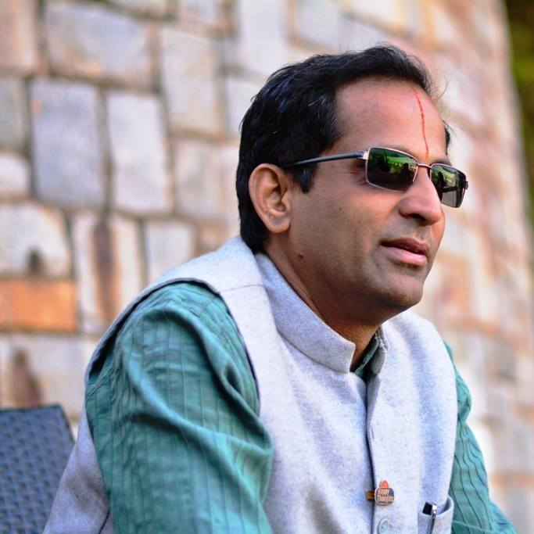

PERSONAL DETAILS
Name (as in passport) |  |  |  |  |  |  |  |  |  | Nationality
Chariar Vijayaraghavan Madhavan |  |  |  |  |  |  |  |  |  | Indian
Date of Birth |  |  |  |  |  |  |  | Place of Birth |  | Marital Status | Category
1 | 6 | 0 | 8 | 1 | 9 | 6 | 9 | Chennai | Tamil Nadu | Married | General
Mailing Address  Centre for Rural Development & Technology  Indian Institute of Technology Delhi  Hauz Khas, New Delhi-110016  India |  |  |  |  |  |  |  |  |  | Communication  T. +91 11-2659 6358 (O) 2659 1592 (R)  Mobile : +91 98 11 64 63 58  E : chariarv@rdat.iitd.ac.in, chariarv@gmail.com  Skype ID : chariarv

EDUCATION
Degree | Institution | Year | Discipline
Ph.D. | IIT Delhi | 1999 | Physics
M.Tech. | IIT Delhi | 1993 | Solid State Materials
M.Sc. | IIT Bombay | 1991 | Physics
B.Sc. | University of Bombay | 1989 | Physics

ACADEMIC AWARDS & PROFESSIONAL HONOURS
  - Titan Design Impact Award 2019
  - Jury Member, FICCI India Sanitation Coalition Awards, 2017
  - Adjunct Faculty, GIOS, Arizona State University, 2017
  - Zerodor ranked in Top 25 Innovative Startups by IIT Delhi Alumni Association, 2015
  - NextBig100 Company Award for Ekam Eco Solutions from The Hay Group , 2015
  - Senior Sustainability Fellow, GIOS, Arizona State University, 2015-2020
  - Member, National Task Force on Rural Housing & Habitat, Min of Rural Dev, GoI, 2014-19
  - Millennium Alliance Award 2014 to Ekam Eco Solutions
  - DST Lockheed Martin India Innovates Growth Prog. Award 2014 to Ekam Eco Solutions
  - PEER Science Awardee, National Academy of Sciences & USAID, 2013
  - Core Group Member, Global Phosphorous Research Coordination Network 2012-2017
  - Fulbright Visiting Professor, Arizona State University, USA, 2012
  - Teaching Excellence Award, IIT Delhi, 2011
  - Member, Empowered Committee on Rural Housing, 2011-2015
  - Member, Sectoral Innovation Council, Min of Drinking Water & Sanitation, GoI, 2010-2015
  - KVIC Golden Jubilee Award for Rural Industrialization Innovations, 2007
  - Young Scientist Award, Forum of Scientists for Peace & Development, 1997
WORK EXPERIENCE (20 Years)
University / Organisation | Designation | From | To | Total  Period | Nature of Experience
Joy Is You  TBIU, IITD | Hon Chairman | Oct 2019 | Ongoing | 1 M | Entrepreneurship
Ekam Eco Solutions, TBIU, IITD | Hon Chairman | Jan 2013 | Ongoing | 6 yr + | Entrepreneurship
Centre for Rural Development and Technology, IIT Delhi | Professor | Jan 2017 | Ongoing | 2 Yrs 10 M | Teaching and Research  (Sustainable Development)
Centre for Rural Development and Technology, IIT Delhi | Associate Professor | Dec 2010 | Dec 2017 | 7 Yrs | Teaching and Research  (Sustainable Development)
Centre for Rural Development and Technology, IIT Delhi  Joint appointment in Values Centre, IIT Delhi | Assistant Professor | Jan 2005 | Dec 2010 | 5 Yrs 11 M | Teaching and Research  (Sustainable Development)  Teaching and Research  (Wisdom based Leadership)
Dept of Humanities & Social Sciences,  IIT, Kharagpur | Assistant Professor | Dec 2003 | Jan 2005 | 1 Yr + | Teaching and Research  (Science, Technology and Society)
Dept of Humanities & Social Sciences,  IIT, Kharagpur | Visiting Faculty | Dec 2002 | Dec 2003 | 1 Yr | Teaching and Research  (Science, Technology and Society)
Physics Group,  BITS, Pilani | Lecturer | Nov 2000 | Dec 2002 | 2 Yrs 1 M | Teaching and Research (Physics, (Science, Technology and Society)
NISTADS (CSIR)  New Delhi | Research Associate | Apr 1999 | Nov 2000 | 1Yr 7 M | Research in History of Science and Technology

Details of Current Research Areas

- Assessment, Validation and Innovation of Traditional Knowledge in sectors including
Traditional Medicine, Artisanal Technologies and Traditional Building Materials
- Design and Development of innovative products and systems for promoting conservation, improving ecology, enhancing inclusion and livelihoods
- Design and Development of Closed-loop Ecological Sanitation Systems, Waterless Urinals, Source Separation Toilets and Nutrient Recovery Reactors
- Disseminating the model of Wisdom-based Leadership & Wisdom-anchored Value
Education for students, professionals and institutions

TEACHING EXPERIENCE
Post Graduate  - Technology Alternatives for Rural Development (IITD)  - Rural India and Planning for Development (IITD)  - Traditional Knowledge and Values (IITD)  - Professional Ethics & Social Responsibility (IITD)  - Business Ethics (IIT KGP)  - Society, Science and Technology (IIT KGP)  - History of Science and Technology (IIT KGP) | Graduate  - Design for the Developing World (Arizona State University)  - Science and Humanism (IITD & IIT KGP)  - Indian Traditions of Science & Technology (BITS Pilani)  - Structure & Properties of Materials (BITS Pilani)  - Thermodynamics (BITS Pilani))  - Physics-I (BITS Pilani)  - Instrumental Methods of Analysis (BITS Pilani)  - Measurement Techniques-I (BITS Pilani))

RESEARCH PUBLICATIONS
Category | Published | Under Review
a. Publications in Referred journals | 20 | 10
b. Publications in Conferences | 30 | 05
c. Books and Monographs | 07 | 02
d. Chapters in Books / Monographs | 06 | 03
d. Patent/copyright obtained/filed | 02 | 03
RESEARCH GUIDANCE
Level of Guidance | Completed | Ongoing
- Doctoral Level | 10 | 08
- Masters Level | 05 | 05
- Bachelor’s Level | 02 | 02

Link to Detailed CV of Course Coordinator
http://web.iitd.ac.in/~chariarv/CV.pdf

