CERTIFICATE PROGRAM IN

SPORTS

ADMINISTRATION

AND

MANAGEMENT

CERTIFICATE PROGRAM IN

Sports

Administration and

Management

Duration:

4 Weeks

Course Type:

Immersive and Practical

Total Number of Learning Hours:

Number of Contact Hours: 60

Number of Immersion Visits' Hours: 30

Total Number of Program Delivery Hours: 90

COURSE DESCRIPTION

“If you do what you love, then you

don't have to work a day in your

life”

– Confucius

We are witnessing a 'Sporting' revolution,

both on and off the fields and arenas. The

rapidly evolving Sports industry needs

professionals who will utilise their expertise

to shape it in the years to come. The

advent of multiple sporting leagues

necessitates the requirement of individuals

who will complement the performances of

sportspersons on the field, with their efforts

off it, and in the process, steer the Sports

industry to newer heights. Those who are

passionate about Sports can have fulfilling

careers as Managers in this growing

industry. Sports Managers are the unsung

heroes, who with their expertise and

enterprise, create just the right environment

for our sporting icons to do the country

proud.

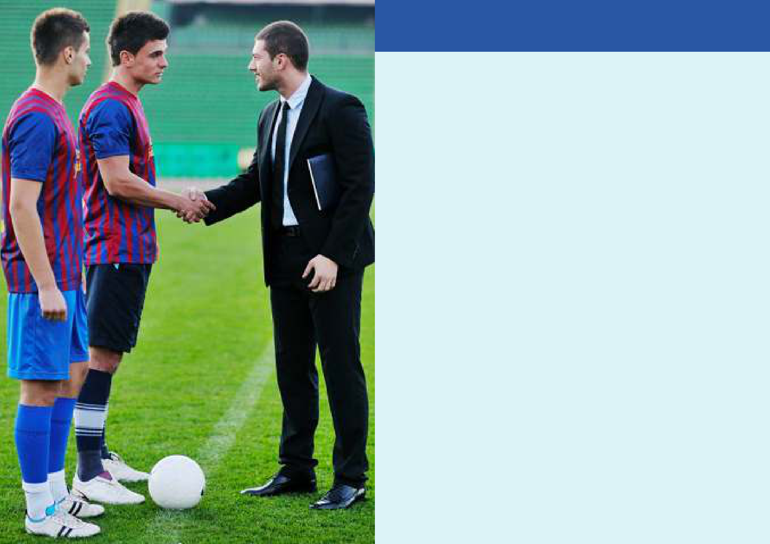
COURSE DESCRIPTION

With sports turning into an ever-expanding, multibillion-dollar industry, career options in allied fields are also finding many takers. Think sports management, sports law, or sports medicine — the number of subsets within the industry have opened up a plethora of opportunities for aspirants. The highly competitive field of sports management provides sports minded people with a head for business opportunities for exciting careers in the world of athletics. Sports management professionals work as team managers, athletic directors, sports agents and recruiters, marketing and PR professionals, and more. People who work in sports management are interested in both sports and business. In school, sports management professionals learn about finance, marketing, law, and business as they apply to the world of sports. Sports management is a great opportunity for many professionals to have very successful careers because the athletic industry generates hundreds of billions of dollars a year. This course is an analysis of effective management strategies and the body of knowledge associated with pursuing a career in sport management. The course introduces the student to sport management career opportunities and to sport principles as they apply to management, leadership style, communication, motivation and entrepreneurship.

At the end of this certification program, every participant is expected to:

- Apply theory and function to planning, organizing, leading, and evaluating in the sport management field;

- Justify the intellectual relationship between quantitative and qualitative tools, theories and sport context in order to effectively predict problems for sports organizations. For example: how to increase ticket sales for sports teams?

- Assess new and innovative business opportunities to strategically navigate the complex demands of the current and dynamic national and international sports business environments using technology and innovations. For example: help a professional team improve the visibility of its sponsors on all format and properties; Identify how entrepreneurship is applied to sport management and evaluate career goals by researching specific areas of sport to determine interest and/or aptitude.

EXPECTED

LEARNING OUTCOMES

- Combine various types of marketing data (i.e. consumer behaviour, loyalty programs and rewards) and apply common analytical methods to generate helpful insights for decision making in sports. For example: analyse the current and future prospects of a broad range of statistical methods and predictive analytics techniques to the benefit of local sports teams.

- Analyse case studies of strategic events in sport to determine effectiveness of management and decision making and evaluate the viewpoints and theories of major sport practitioners in the sport management field; and

- Define the various components of sport marketing, such as; marketing plans, marketing niches, marketing needs, and advertising.

EXPECTED

LEARNING OUTCOMES

- Classroom Lectures, discussions, debates, business model development & refinement

- Innovative pedagogical tools – like case studies, video cases, industry reports, live conversations with sports management professionals and immersion visits to sports management facilities, etc – would be deployed for better learning outcomes

- The focus would be to refine professional approach to sports management

TRAINING METHODOLOGY

DETAILED SYLLABUS

WEEK 1

DAY 1

Introduction to

Sports Management

This module emphasizes basic management principles as they relate to the sports-related enterprises.

A variety of marketing techniques and approaches are analysed to broaden students' background in this area and to better allow them to develop effective and comprehensive sports marketing plans

DAY 2

Sports and

Recreation Marketing

This module focuses on marketing issues as they relate to sports-related enterprises. A variety of marketing techniques and approaches are analysed to broaden students' backgrounds in this area and to better allow them to develop effective and comprehensive sports marketing plans.

DAY 3

Public Relations and

Advertising for the

Sports Industry

This module provides a cross-disciplinary approach to a variety of promotional issues that sport managers routinely confront. Public relations and advertising professionals offer insights into how sports-related endeavours and businesses can raise public awareness about products and services.

DAY 4

Sports Tourism

This module examines the relationship between sport travel and the tourism industry. As more people choose to travel to attend or participate in sporting events, a branch of the hospitality and tourism industry has developed to focus on the needs of these clients. Youth sport tourism, for example, has become a $7 billion industry in the United States alone. The study of sports tourism draws upon the disciplines of management, finance, economics, event planning and marketing

DAY 5

Immersion

Visit I

DETAILED SYLLABUS

DAY 1

Sports and Fitness

Facilities Management

This module exposes students to the many elements and dynamics associated with managing a sports or fitness facility. Students will visit a variety of structures, arenas, and facilities and will gain an understanding of what is required to develop and successfully administer and market such facilities

WEEK 2

DAY 2

Sports Communications

This module seeks to provide the student with an appreciation of the unique dynamics associated with the sports communication field. Students will better understand the expectations associated with developing a sports story, a sports news release, and/or a sports opinion piece, via traditional print media or electronic media - radio, television, and/or the Internet. A review of journalistic ethics will be included. Students will gain first-hand experience with regard to producing television and radio broadcasts of live sporting events

DAY 3

Introduction to

Sport Analytics

Data analytics can be applied to every functional area of sport business, from marketing to event management to player performance. Using research spanning the sport industry, students will develop a working knowledge of data analysis as it applies to business decisions across the sport industry.

DAY 4

Ticketing Operations in the Sports Industry

Ticket sales are vital to entertainment and sports organizations' long-term success. Without people in the entertainment venues, companies can't attract sponsors. Tickets sales are a complex activity that goes well beyond the act of selling. This course focuses on tickets sales strategies and promotion processes highlighting the fundamental concepts, principles and application associated in this strategic area of entertainment and sport management. Students will learn how to use different standards and principles as it relates to the ticketing industry with all its different operations facets. The goal is to provide a cross-disciplinary approach to a variety of marketing, sales and promotions issues that confront managers: how to leverage ticket sales as a revenue source in sports and entertainment industries. It also examines sales strategies for single-game, season ticket, and group sales; ticket office operations; and building a database for ticket sales.

DAY 5

Immersion

Visit II

DAY 1 DAY 2

DETAILED SYLLABUS

DAY 3 DAY 4 DAY 5

Sports and Recreation Law

This module focuses on the legal issues unique to the sports world and to sport managers. Numerous case studies and precedents are examined, as well as how they relate to current situations involving professional, intercollegiate, interscholastic and community sports and athletic activities.

WEEK 3

Leadership in the

Sports Industry

The sports industry is one of the largest and most important industries in the world. It provides products and services for worldwide audiences. Technologies transform the way sports & games' shows are created and distributed challenging many companies in the sector in areas like finance, production and distribution of content. This module prepares participants to accelerate their career in sports industry through the exploration of leadership skills. Topics include project development, strategic marketing, emerging technologies, and various stakeholders' strategies in the making and television productions but also sports content. Participants will learn from industry leaders and gain professional experience at major studios, networks, agencies, and production companies.

Sport Venues and IMMERSION VISIT III Immersion

Event Management Visit IV

With new arenas, stadiums,

health clubs, convention centres,

and other facilities popping up all

over the nation, numerous job

opportunities are available in this

discipline. Even in these tough

economic times when some jobs

are harder to find, there is still a

significant need for properly

trained sport facility managers.

This class will cover numerous

issues from construction-related

concerns to marketing facilities,

naming rights, and concession

concerns. Also covered will be

topics related to the facility

management side of the industry,

with special attention paid to

back-of-the-house operations

such as water, heating, cooling,

and related activities. This is a

comprehensive course focusing

on applied rather than theoretical

knowledge. To learn some of the

hands-on elements of running a

facility, students will visit a major

sporting facility.

WEEK 4

DAY 1

Sports and Society

This module is designed to raise awareness with regard to the sociology of sport and how cultural practices in the world of sport can have significant social, economic, and political consequences. Discussion and research should give future sport managers a broader understanding of how sport impacts different groups of people in different ways throughout this country and beyond.

DETAILED SYLLABUS

DAY 2 | DAY 3 | DAY 4
Financial Principles | Sporting Goods Industry | Sports Agency
a. Tapping New Revenues | a. History of Sporting | a. Growth of the Sports
b. Doing More with Less | Goods/Licenses Products | Agency Business
 | b. Key Industry Segments -- | b. Collective Bargaining
c. Concessions/Luxury Seating
 | Equipment, Footwear, Apparel | Agreement
d. Seat Licenses PSLs
 | c. Trade Associations | c. Standard/Uniform Player
e. Corporate Sponsorship and
 | d. Career Opportunities/Current | Contract
Licensing
 | Issues/Case Issues | d. Representing Individual
 |  | Athletes/Coaches
 |  | e. Sports Agency Firms
 |  | f. Career Opportunities
 |  | e. Case Studies Reviewed

DAY 5

Conclave

Professionals’

Management

Sports

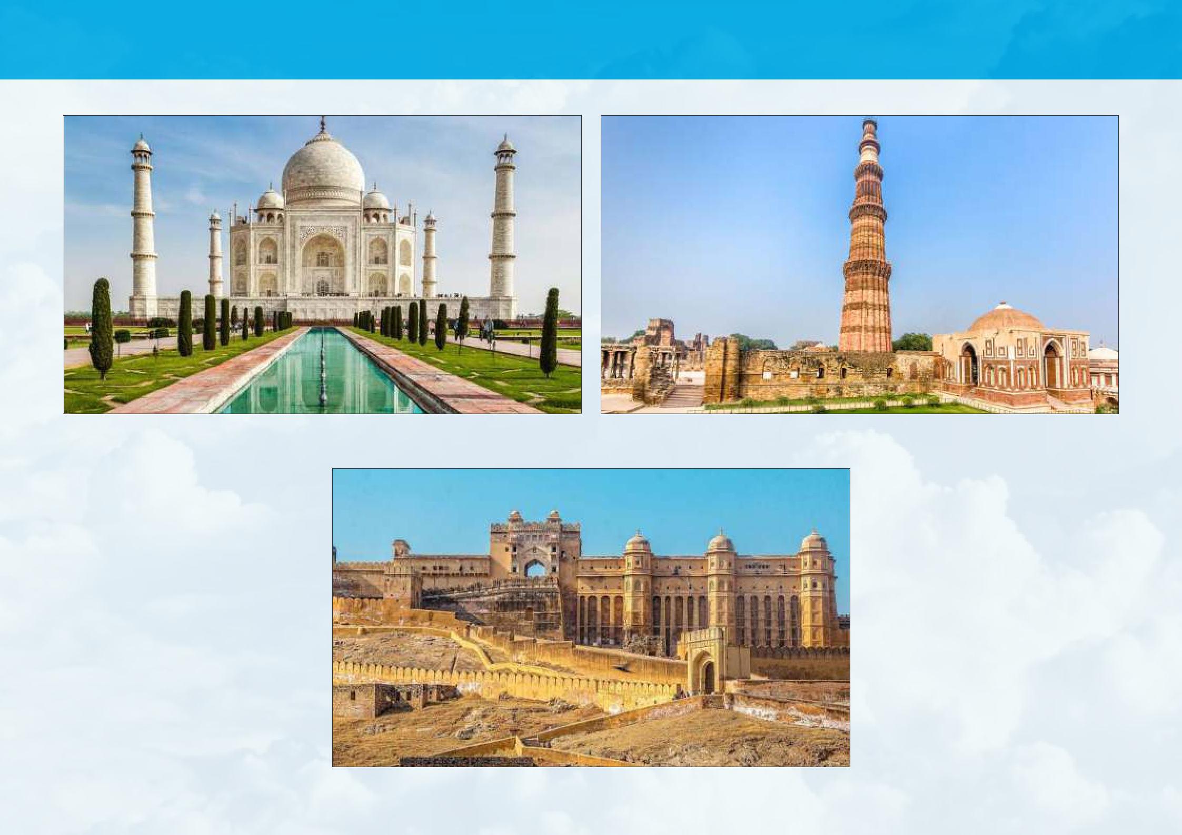
INDIAN CULTURAL IMMERSION TOUR

Taj Mahal - Agra Qutub Minar - Delhi

Amber (Amer) Fort - Jaipur

