RECENT ADVANCESIN HARVEST AND POST-HARVEST TECHNOLOGIES IN FISHERIES

(Date: OCTOBER 28 –NOVEMBER 10, 2021)
IST 11:00 to 13:00 hrs

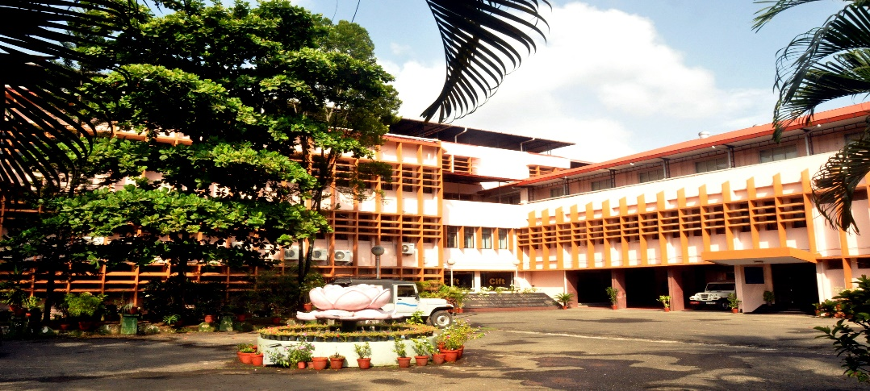

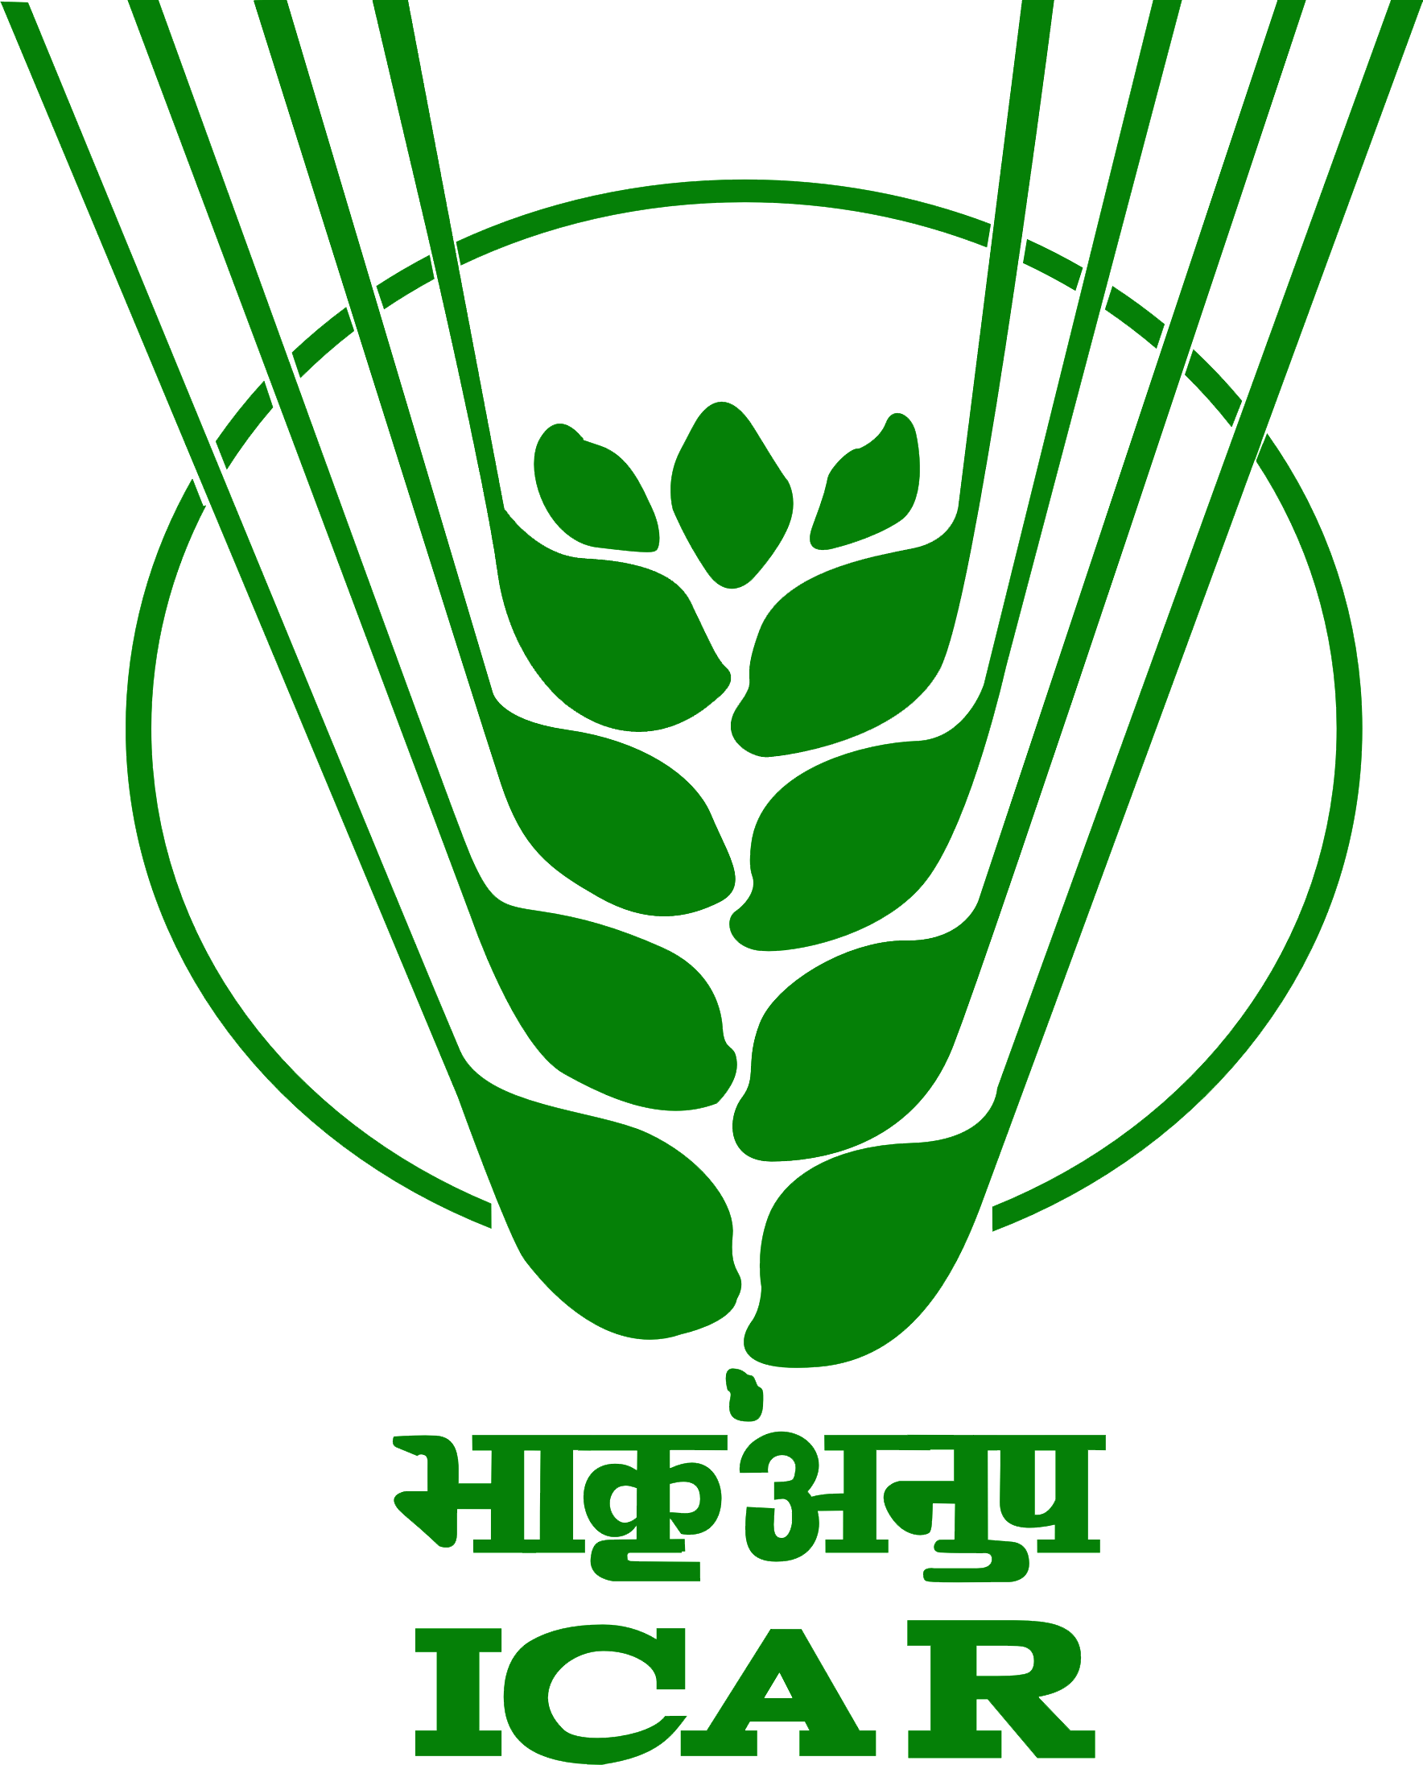
ICAR - Central Institute of Fisheries Technology
(ISO/IEC 17025 :2005 Accredited & ISO 9001 :2015 Certified)
CIFT Junction, Matsyapuri P.O., Kochi - 682 029, Kerala
Ph: 091-0484-2412300, Fax: 091-484-2668212, E-mail: cift@ciftmail.org, directorcift@gmail.com
URL: www.cift.res.in.
ICAR - Central Institute Of Fisheries Technology
(ISO/IEC 17025 :2005 Accredited & ISO 9001 :2008 Certified)
CIFT Junction, Matsyapuri P.O., Kochi - 682 029, Kerala
Ph: 091-0484-2412300, Fax: 091-484-2668212, E-mail: director.cift@icar.gov.in, directorcift@gmail.com

director.cift@icar.gov.in
directorcift@gmail.com
Fax: 091-484-2668212
ICAR - Central Institute Of Fisheries Technology
(ISO/IEC 17025 :2005 Accredited & ISO 9001 :2008 Certified)
CIFT Junction, Matsyapuri P.O., Kochi - 682 029, Kerala
Ph: 091-0484-2412300, Fax: 091-484-2668212, E-mail: director.cift@icar.gov.in, directorcift@gmail.com

director.cift@icar.gov.in
directorcift@gmail.com
Fax: 091-484-2668212

ICAR- Central Institute of Fisheries Technology
ICAR-Central Institute of Fisheries Technology (CIFT), a pioneer research institute under the aegis of Indian Council of Agricultural Research (ICAR) has been playing a pivotal role in pursuing its research and extension activities in harvesting and post harvesting sectors in fisheries during its fruitful existence since last six decades. Since its inception during 29th April, 1957; the institute has been instrumental in modernizing the fishing and fish processing sectors in the country and continues to impart technological support to a broad spectrum of stakeholders comprising of fisher folk, students, extension professionals, seafood industries, fish entrepreneurs, faculties and scientists through well designed skill oriented training programmes.

The major activities of the institute centers around evolving innovative and cost effective technologies for fish harvesting, development and standardization of different post- harvest practices, techniques for extraction of biomedical, pharmaceutical and industrial product from aquatic organisms, biotechnological approaches for disease diagnostic tools; quality management and maintaining food safety standards; design and development of tools and techniques for harvesting and storage and at the end transferring the technologies to end users through training, education and extension programmes with the involvement of highly qualified and experienced faculty scientists from seven different divisions viz., Fishing Technology, Fish Processing, Quality Assurance and Management, Microbiology, Fermentation and Biotechnology, Engineering and Extension, Information and Statistics Division.

Institute mandates
- Basic and strategic research in fishing and processing.
- Design and develop energy efficient fishing systems for responsible fishing and sustainable management
- Development of implements and machinery for fishing and fish processing.
- Human resource Development through training, education and extension.

On the human resource development front, the Institute continues to offer its premier technical expertise and advice in the areas of fishing, fish processing, quality management, food safety, nuetraceuticals development etc. on a continuously evolving basis. The Institute offers regular, comprehensive, specialized and certificate training programmes on responsible fishing, fish processing, value addition, and packaging and quality control systems for the benefit of researchers, prospective entrepreneurs, industry personnel, extension professional, students alike and also International training programmes under ITEC and SAARC regional training programmes.

The infrastructural facilities at ICAR-CIFT include NABL accredited laboratories, FSSAI accredited National level Referral and Reference Laboratory for fish and fish based products, Fish Behaviourlaboaratory, Craft and Gear Workshop, research vessels, Pilot processing plant for value added fish products development, Engineering Workshop, ATIC, well equipped AV aided digital class rooms and Conference Hall. The Institute also has an Agri- Business Incubation (ABI) Centre to promote business incubation activities and start-up ventures in post-harvest fishery technologies.
Background of the Course
Fisheries make critical contributions for the food and nutritional security of over 41 million people worldwide, the vast majority of whom live in developing countries, out of which India alone shares more than 15 million i.e. nearly 1/3rd of the global figure. Fish is not only an important and affordable source of animal protein and varied nutrition for the million poor, but it plays an important role in livelihood development bycreating avenues for large scale employment opportunities with a wide scope for export trade. Better fish harvest technologies facilitate conservation and sustainable fishing; while postharvest technologies help in income enhancement, employment generation and entrepreneurial prospects leading to betterment of the livelihood standards of populations. The present course is proposed considering the vital importance of human resource development and capacity building in advance techniques of fish harvesting and post harvesting for effective development of fishery sector in ITEC partner countries all over the world.

Key Focus areas of the Course
The proposed training course shall emphasize on recent advances in fish harvest and post- harvest technologies suitable for different eco-system in African, Asian and Latin American countries under ITEC, which are as follows:
- Improved and cost effective technologies for fish harvesting andresponsible fishing
- Development and standardization of different post-harvest protocols and practices, value addition, and packaging techniques
- Advanced techniques for extraction of biomedical, pharmaceutical and industrial product from aquatic organisms,
- Modern biotechnological tools and approaches for fish disease diagnostic and surveillance
- Quality control, management and maintaining food safety standards in fish and fish based products
- Design and development of tools and techniques for harvesting and storage of fishes
- Innovative extension management techniques, value chain development, gender and entrepreneurship in fisheries for livelihood security.

Broad outline of the Course
Recent trends in Fish Harvesting

- Importance of responsible fishing and its strategic implementation for sustainable fisheries
- Improved fishing gear materials
- Design and operation of energy saving in fishing vessels/trawls
- By-catch reduction devices in trawling
- Nano application in material protection
Advance techniques of Fish Processing
- Handling and chilled storage of fish
- Low temperature preservation of fish products
- Thermal and Non-thermal processing of Fish
- Smoking of Fishes
- Developing Value added fish products
- Extruded fish products
- Vacuum packaging & MAP
- Seafood packaging

Fish waste management and nutraceutical development
- Protocols for production of high value secondary products from industrial fish and shellfish
- Nutraceuticals from Fish and Fish Wastes: Scopes and Innovations
- Profiling of macro and micronutrients in sea food
- Microencapsulation for seafood fortification

Post –Harvest Engineering in Fisheries
- Technological innovations in fishery engineering
- Novel drying techniques in fish processing and preservation
- Preprocessing of fish and solar fish drying

Maintenance of quality and safety standards in Fisheries
- Microbial techniques for hygienic standard maintenance in sea-foods and aquaculture
- Prophylactic Health Products in aquaculture
- Antimicrobial resistance (AMR) in aquatic products
- Designing Food Safety Management System
- Seafood quality assurance and safety regulations
- Determination of chemical and biological contaminants in seafood
- HACCP Concepts
Innovative extension management techniques, value chain developmentin fisheries

- Innovative extension methods for technology dissemination in fisheries
- Prospects of micro-financing for livelihood development in fisheries sector
- Gender impact on community based Fishery Development
- Assessment of harvest and post-harvest losses in fishery value chain
- Improving input and service delivery system in fisheries
- Technology Application, Refinement and Transfer through KVKs
- Developing suitable EDP module for fish-preneurship

