International Training on Vaccine and Cold Chain Management (T-VaCC) for ITEC

Introductory Document

The National Institute of Health and Family Welfare
New Delhi
National Cold Chain and Vaccine Management Resource Centre

Training on Vaccine and Cold Chain Management (T-VaCC)

Training Team
Course Coordinator: Prof. Harshad Thakur, NIHFW
Dr. Renu Shahrawat

Course Co-coordinator: Dr. Snehil, NCCVMRC, NIHFW

Course Associate: Mr. Manish Kumar, NCCVMRC, NIHFW
Mr. Shashi Kant Ray, NCCVMRC, NIHFW
Mr. Rakesh Kumar, NCCVMRC, NIHFW

The National Institute of Health and Family Welfare
National Cold Chain and Vaccine Management Resource Centre
Ministry of Health and Family Welfare
Government of India

OVERVIEW OF THE TRAINING
Immunization forms an important component in any country’s public health program. Proper maintenance of cold chain and management of vaccines are crucial for ensuring an effective immunization supply chain (ISC) in the health system and realizing the objectives of immunization viz. prevention of vaccine preventable diseases (VPDs), reduction of morbidity and mortality due to VPDs, and consequent improvement in overall health.
India’s Universal Immunization Program (UIP) is one of the largest immunization programs in the world, catering to nearly 26 million infants and 29 million pregnant women annually. To improve health systems and immunization outcomes in this country, many initiatives have been taken by the Ministry of Health and Family Welfare (MoHFW), Government of India. It has established the National Cold Chain and Vaccine Management Resource Centre (NCCVMRC), located at the National Institute of Health and Family Welfare (NIHFW), New Delhi, with a vision to facilitate establishment of a high-quality, effective and efficient ISC in India to ensure universal immunization coverage with safe and potent vaccines.
Over the years, several gaps have been identified in cold chain infrastructure, human resources, stock management and monitoring of cold chain and logistics in various countries. With this background, the NCCVMRC has developed a unique training – the Training on Vaccine & Cold Chain Management (T-VaCC) – to address the gaps of knowledge and skills in vaccine and cold chain management among immunization program managers at all levels of the ISC. It is a techno-managerial training to build capacity of immunization program managers so that they may perform their works related to vaccine and cold chain management more effectively and efficiently.
The T-VaCC has been developed by NCCVMRC as a progressive expansion of its earlier national training course namely the Effective Cold Chain and Vaccine Management Course (ECCVMC). The ECCVMC was piloted during April-May 2015 as a five-day training, followed by successful conduction of seven national batches of it, with imparting training to a total of 149 senior and mid-level immunization program managers in India. After the success of this training at national level, it was envisaged to take it to an international level too. Accordingly, the T-VaCC has been refined further and developed as a five-day (physical) training for immunization program managers working in different countries and dealing with vaccine and cold chain management at various levels in the ISC system.
The first international batch of T-VaCC was conducted in September 2018 at Kathmandu, Nepal. Where NCCVMRC, NIHFW team trained officials from 8 countries and second batch was conducted in July 2019 in Male, Maldives, where again participants from 8 countries were trained on the topic.
Considering the current COVID-19 pandemic scenario, same course was transformed into an online mode, through which more than 50 participants from India have been trained. For the first time, it is being proposed for International audience in an online mode, in an 5-Day training design.

ABOUT NIHFW
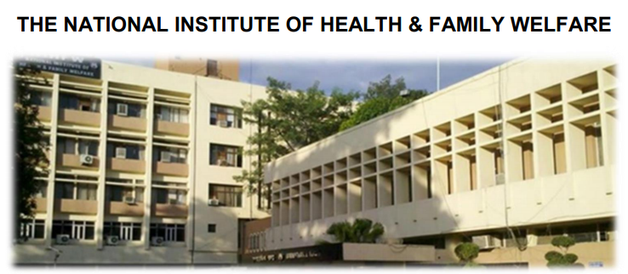
The National Institute of Health and Family Welfare (NIHFW) played a vital role in COVID-19 vaccine introduction in India The NIHFW, an autonomous organization, under the Ministry of Health and Family Welfare, Government of India, acts as an apex technical institute as well as a think tank for the promotion of health and family welfare programs in the country. Its mission is to act as a, catalyst & innovator for management of public health and related health & family welfare programs by pursuing multiple functions of Education & Training, Research & Evaluation, Consultancy & Advisory services as well as provision of specialized services through inter-disciplinary teams. NIHFW is a pioneer for in-service training.
Being a leader on education and training front in country, NIHFW plays a vital role in Immunization Cold Chain Management via a National Center on Immunization Supply Chain, i.e. National Cold Chain and Vaccine Management Resource Center (NCCVMRC), which is situated and completely guided by NIHFW.

ABOUT NCCVMRC
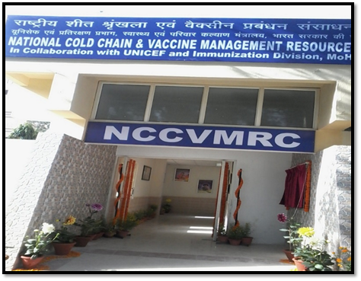
The National Cold Chain and Vaccine Management Resource Centre (NCCVMRC), placed in the National Institute of Health & Family Welfare (NIHFW) New Delhi, is the apex body of MoHFW, GoI to provide technical support on country’s immunization supply chain. The centre was established in 2013 as a joint initiative of the Ministry of Health & Family Welfare (MoHFW), NIHFW and UNICEF. It was formally inaugurated by the Union Minister of Health & Family Welfare, Government of India, on 9th March 2015.
NCCVMRC is placed under the direct supervision of the Nodal Officer (Immunization), NIHFW with functional oversight provided by the Immunization Division, Ministry of Health & Family Welfare. UNICEF also provides technical support to the institute for GAVI-HSS activities.
NCCVMRC is the nodal resource centre for all immunization supply chain related research, training, planning and policy initiatives in India. The centre has also been designated as the secretariat for effective vaccine management (EVM) assessment, and for cold chain equipment specifications. The institute undertakes capacity building of program managers and policy makers at all levels. NCCVMRC also coordinates with the National Cold Chain Resource Centre (NCCRC), Pune to conduct training for Cold Chain Technicians (CCTs).

VIRTUAL TRAINING EXPERIENCE OF NIHFW, NCCVMRC

NIHFW is a major stakeholder of capacity building activities for public health in India. Apart from the routine activities conducted by Distance Learning cell, NIHFW has conducted numerous virtual training courses since the ongoing pandemic, examples of some are as follows:
- National batch on Immunization Cold Chain Management for District and State level program officers,
- Skill Based Training of Cold Chain Technicians for repair and maintenance of COLD chain equipment
- Training of data managers in country for MIS,
- Trainings on Epidemiology and Bio Statistics, Hospital Management, Nursing Management Etc.
- International e-Training on COVID-19 Vaccine Rollout

OBJECTIVES OF THE TRAINING
General objective
- To strengthen the skills of immunization program managers at all levels in effective planning, implementation and supervision of vaccine and cold chain management.
The specific objectives of T-VaCC are to:
- Equip participants with the knowledge and skill to identify managerial issues in vaccine and cold chain management;
- Enhance the ability of participants to identify and manage real-world issues in vaccine and cold chain management;
- Ensure understanding of participants about end-to-end vaccine management through a vaccine life cycle approach; and
- Enable participants to effectively handle the vaccine and cold chain management ecosystem, including planning of program and forecasting the immunization supplies.

TRAINING METHODOLOGY
The training will be conducted using an online training platform. The participants will be oriented on the use of this online training platform and algorithm in the course kick off session.
The training will lay particular emphasis on participatory learning and will use a diverse mix of techniques to ensure robust engagement with participants. The training will be covered over an 5-day period using English as the communicating language. The timing of daily session will be maximum up to 3 hours. All the live sessions may be recorded during the training and will be shared with the participants after the sessions.
The T-VaCC will utilize a mix of appropriate training technologies including lecture discussion methods, case studies, group discussions, demonstrations, group exercises and quizzes to practice managerial skills in vaccine and cold chain management. All the sessions will be interactive and will be motivated by the facilitator to ask questions into the chat box. The Co-facilitator will be checking the questions will be putting in front of lead facilitator for real time answer. The participants will do exercises individually and in groups, and will make presentations on their observations and managerial actions. The training performance will be assessed through pre and post-test. At the end of the training, the feedback will be obtained from the participants to bring in further improvements in the program.
Participants will start preparing for the training a couple of weeks before they actually attend the training. They will be provided with background reading material (pre-read material) essential for an adequate understanding of the training contents in advance.

TRAINING CONTENTS
The T-VaCC covers key aspects of vaccine and cold chain management through a mix of theory, exercises, group works, and field visits. The following areas will be covered in the training:
- Vaccine estimation & scheduling
- Vaccine receipt
- Vaccine storage
- Stock management
- Vaccine distribution
- Vaccine wastage
- Vaccine management at Service delivery level
- Temperature monitoring
- Cold chain maintenance
- Supportive supervision in immunization
- Management Information Systems
- Cold Chain Planning
- Effective Vaccine Management and Improvement Plan

TRAINING MATERIALS
The following training materials will be used:
- The Facilitators' Guide
- Session plans
- Standard PPTs
- Case studies
- Photographs and videos
- Exercise sheets and handouts
- Quiz

MATERIAL TO BE HANDED OVER TO PARTICIPANTS
The following training materials will be given to each participant:
- Pre-training reading material (to be sent to participants online, in multiple spells, starting about 10 days before the commencement of the training)
- Training PPTs / other session materials (to be given in secondary data storage devices/ pen drives).

DURATION OF TRAINING
Five days. Maximum of 4.5 hours in a day.
11:00 AM to 1:00 PM
02:00 PM to 04:30 PM

MODE- Virtual/Online platform

LANGUAGE- English

CERTIFICATION
An electronic copy of Course Certificate will be provided to the participants post completion of the training. Only those participants who participate in all the sessions, take the pre and posttest and submit the feedback form will be provided the course certificates.
OUTCOME

The training would contribute into the enhancement of participant’s capacity to ensure the smooth management of vaccine and cold chain in their country. The participants will be able to identify the priority areas as well as how to mitigate the identified challenges. Further, this training may also contribute for overall system strengthening and full immunization coverage with potent vaccines.

