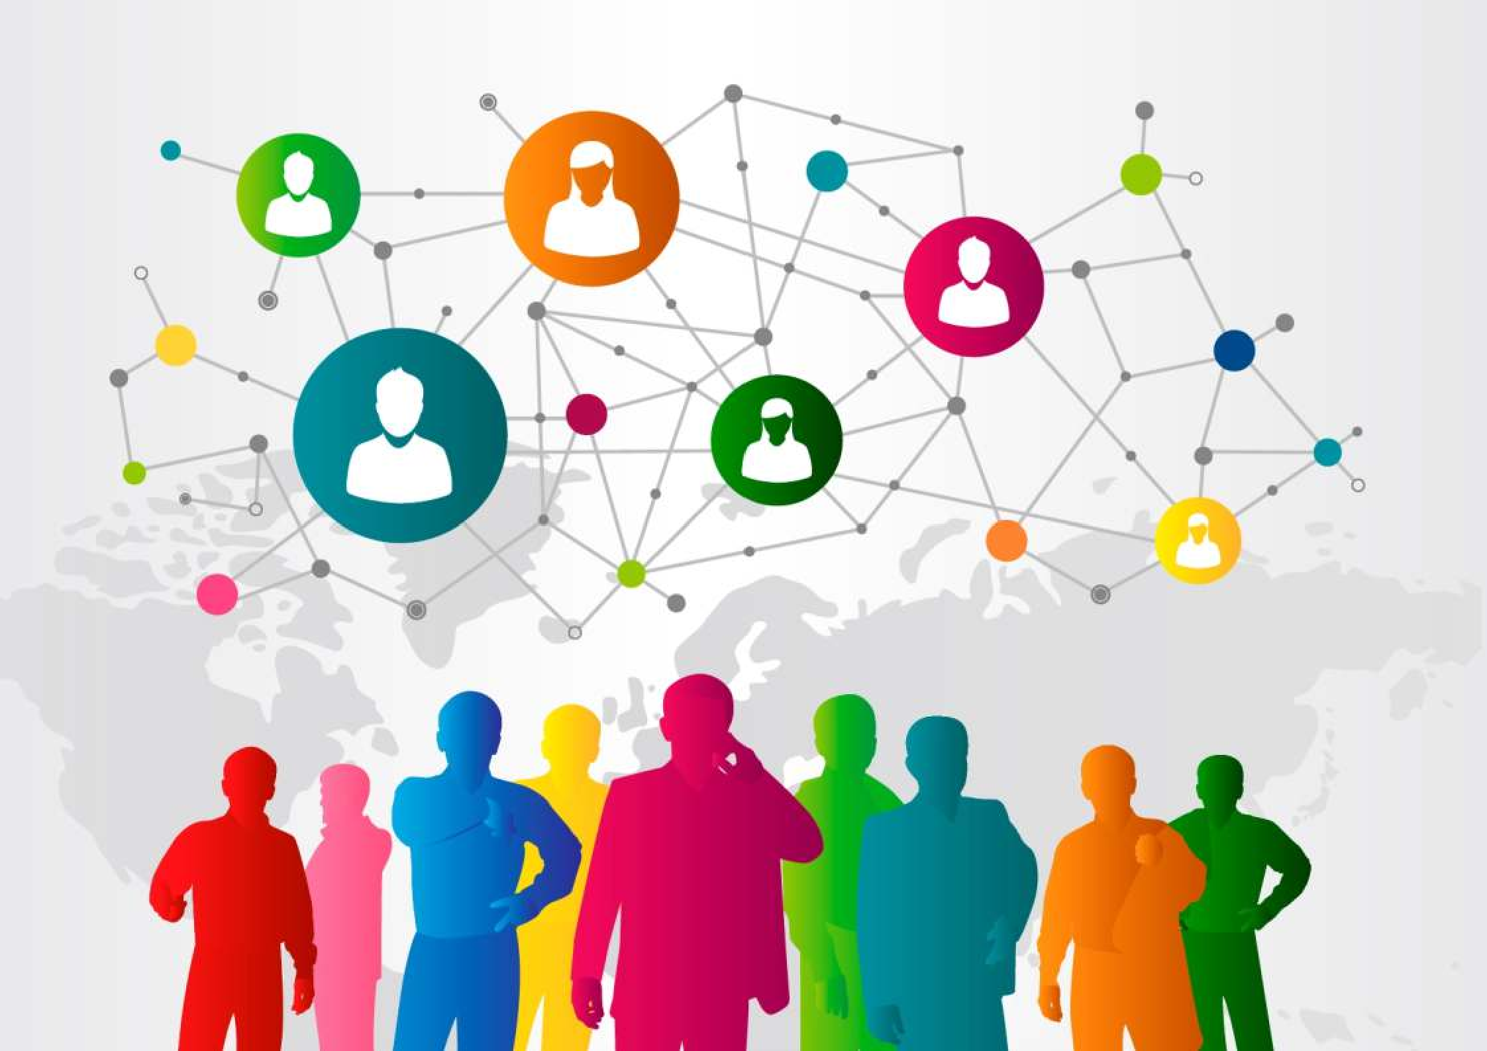

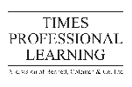



CERTIFICATE PROGRAM IN
ADVANCED COMMUNICATION SKILLS



CERTIFICATE PROGRAM IN
ADVANCED COMMUNICATION SKILLS

Duration:
5 Weeks

Course Type:
Immersive and Practical

Total Number of Learning Hours:
150 Hours

Lectures (L) | Case Studies (C) | Prototype Development and Practice Orientation (P)
20 | 40 | 90



COURSE DESCRIPTION

In any profession, you will find yourself in a situation where you need to relay information to another colleague. When such situations arise, good communication skills are an essential part of getting your message across clearly. This course will show you how to apply advanced verbal and written communication techniques in your workplace. The ability to plan and execute good quality communications in the workplace is one of the key attributes of the modern manager and leader.
Developing this competency is vital to managerial skills enhancement given that effective communication is essential to the current and future success of any organization. However, because we are now operating in a tech-heavy, time-poor environment, not only do leaders need to understand
- they need to be understood – and quickly. Real communication is about first understanding self and then about knowing, with certainty, how other people differ from you and how your message comes across to them. This Certificate Program in Advanced Communication Skills will focus on these elements as the essential basics of communication and then build on several key related skills. This program will also focus on the necessity of developing both personal skill and the right attitude for effective communication.





EXPECTED LEARNING OUTCOMES
At the end of this program, the participants will:
  - Planning to communicate and choosing the right way
  - Creative and systematic approaches
  - Self-awareness of communication style
  - Reading other people and managing their perceptions
  - Presentation skills explained

  - Delivering your message

  - Handling conflict, understanding differences and building confidence



The aim of this certificate program is to provide participants with a practical skill set that will allow them to have
OBJECTIVES
    - An understanding of how to plan and execute communication
    - Awareness of one's communication style
    - How to read and adapt to feedback and body language
    - Increased skill in presenting, questioning, listening and observing
    - Practice and confidence in delivering communications

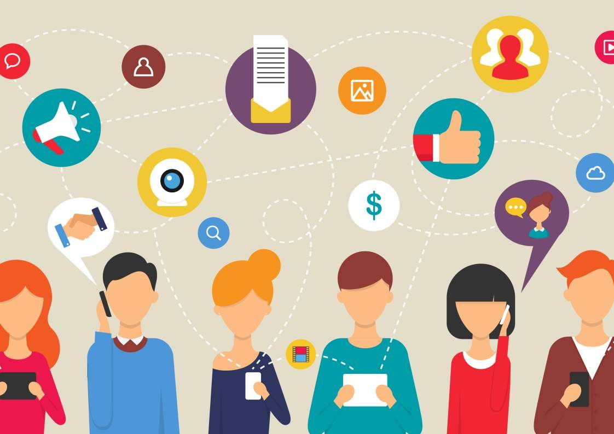


This contemporary, interactive program, titled Certificate Program in Advanced Communication Skills, will challenge and educate participants, using a broad realm of techniques such as tutor input, discussions, case studies and examples, real-play feedback sessions, video inputs and relevant personal communication challenges.

TRAINING METHODOLOGY



The organization can expect participants to:
- Return to work with greater confidence and skill sets for making presentations and communicating with individuals and groups
- Achieve a more reliable and repeatable format for communication across the Company
- Be readier to volunteer to share information and data by way of 1:1 and group conversation
- Look for opportunities to practice their skills and be able to pass on tips to help others

ORGANIZATIONAL IMPACT




The participants can expect to:

- Gain the knowledge and skills required to create communications that get the message across in an interesting and dynamic way
- Learn how to conquer nerves, capture an audience and get them on your side
- Understand, step-by-step, the stages of preparing and executing successful communications

PERSONAL IMPACT

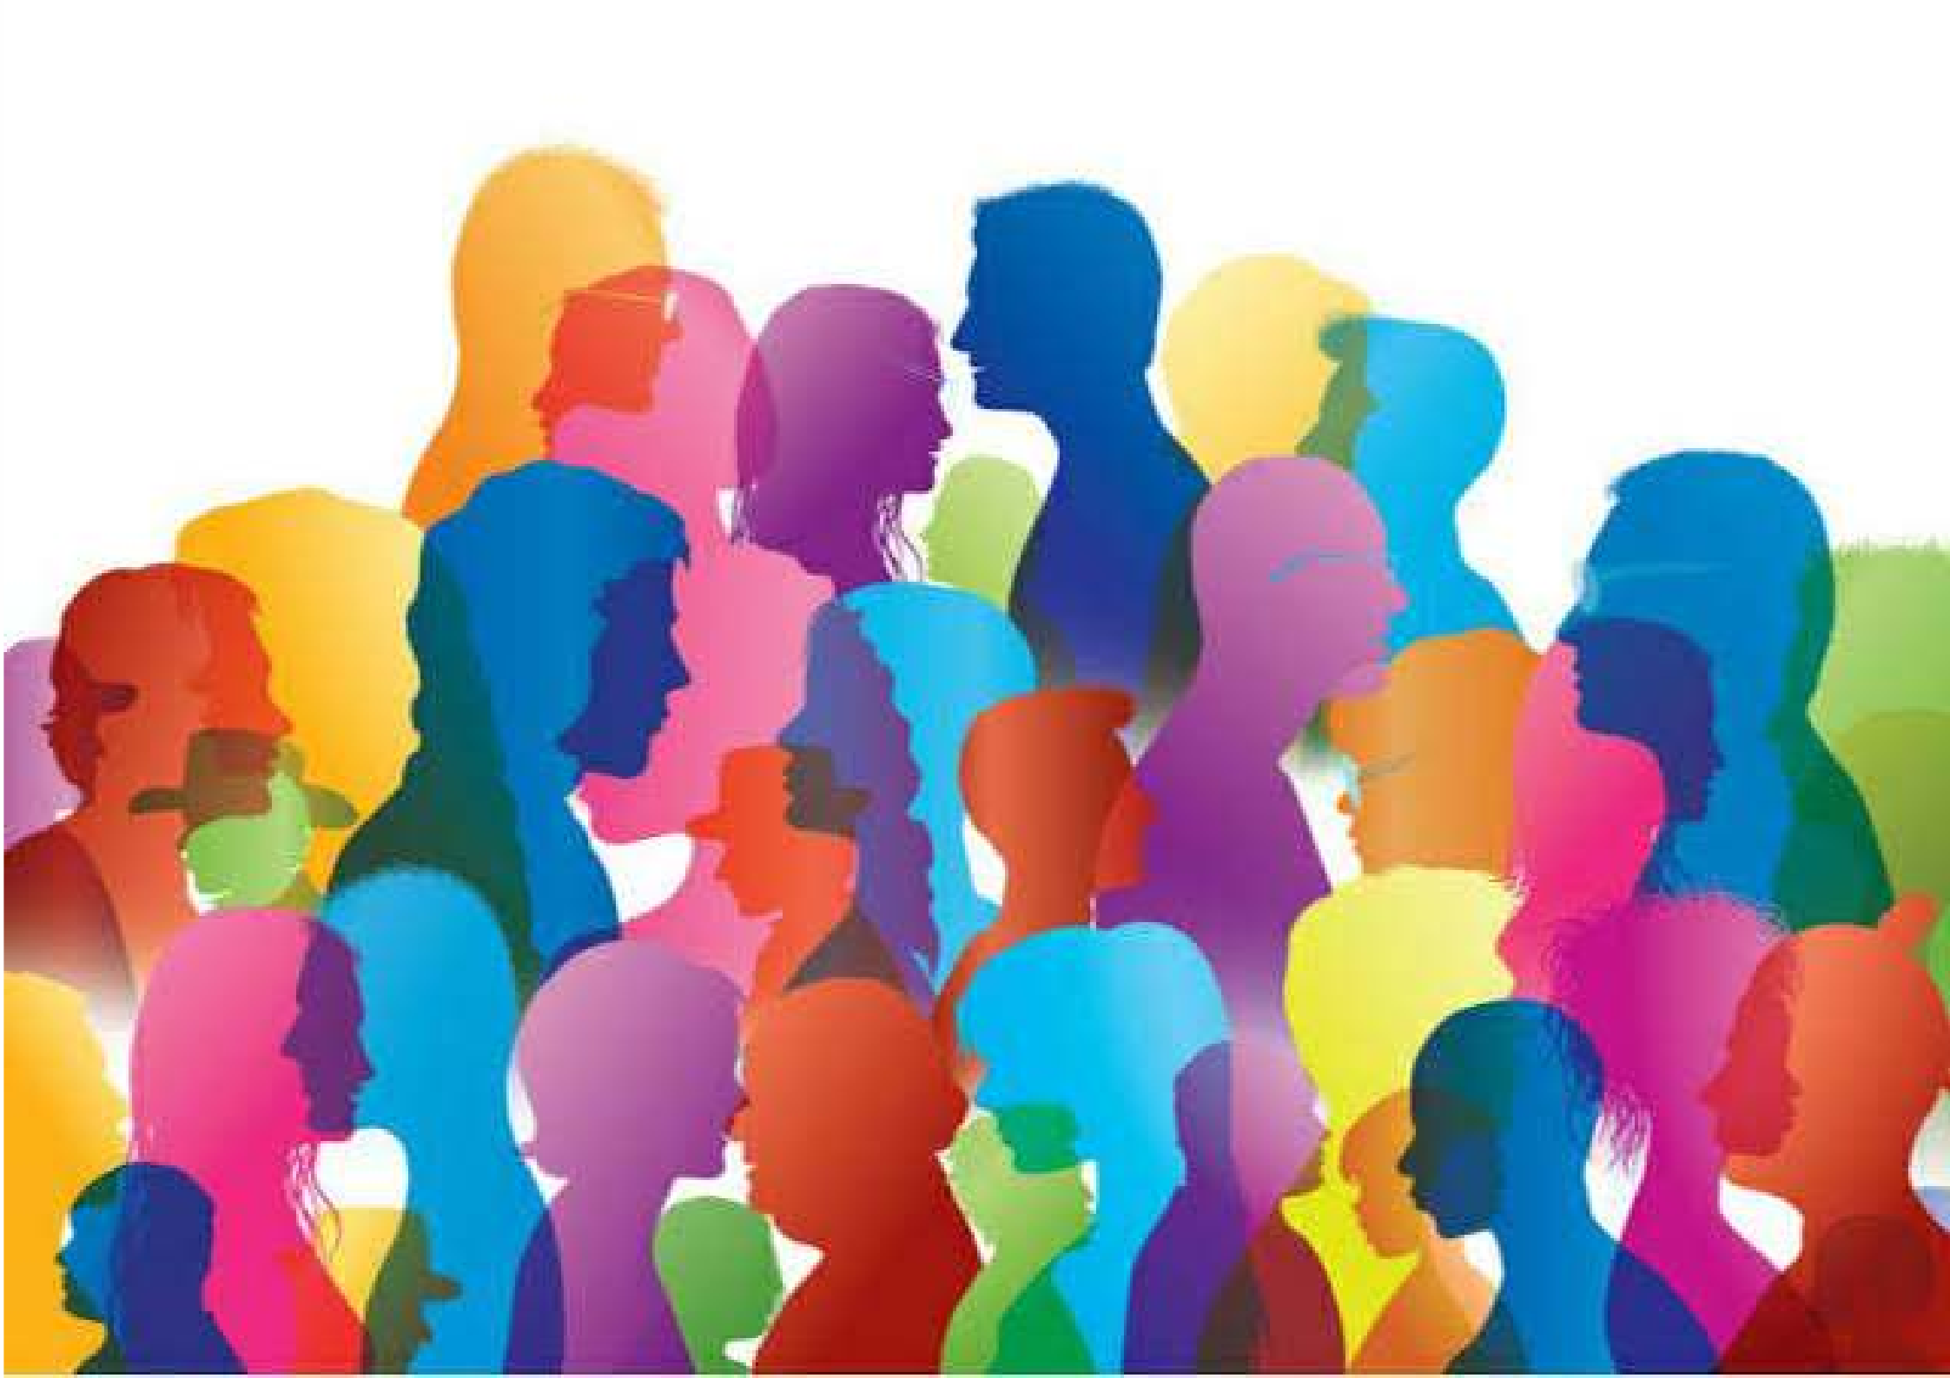


WHO SHOULD ATTEND?

This Certificate Program in Advanced Communication Skills is suitable for anyone who wishes to see a dramatic improvement in his/her professional (and personal) communication skills. Level within the organization is less important than keenness to learn and apply new skills of communication in the workplace.

DETAILED SYLLABUS
WEEK 5
WEEK 4
WEEK 3
WEEK 2
WEEK 1

Communicating Yourself
- What is Communication?
- Types of Communication
- Your Role and Beliefs when Communicating
- How to listen, really listen…
- Reading People
- Developing Self Awareness
Verbal Communication
- Self-awareness and Emotional Intelligence
- Communication Styles
- Para-language
- Understanding the Power of Your Voice and Posture
- Positive and Negative Language
- Giving & Receiving Feedback
Non-Verbal Communication
- The Range of Non-Verbal Communications
- Body Language
- Gestures
- Communicating in Meetings
- Written Communications Outlined

The Art of Presentation
- Preparing to Present
- Planning What to Say (and what not to)
- Visual Aids and Stagecraft
- Using Q&A Sessions to Your Advantage
- Changing Your Emotional State for Success
- Presentation Practice and Feedback
Influence, Persuasion and Conflict Management
- A Model of Persuasion - Push vs. Pull
- Understanding Conflict and Its Positions
- Who do you think you are (and come across)?
- Talking Organizationally
- Cross Cultural Communication
- Planning to Make a Difference





INDIAN CULTURAL IMMERSION TOUR

Taj Mahal - Agra Qutub Minar - Delhi

Amber (Amer) Fort - Jaipur
