Proposed e-ITEC/ITEC Course 2022-23

Title: Emerging Contaminants and Water Reuse

Dates: August 8th,2022-August 19th, 2022

Venue/ Mode: Online

Coordinator: Prof. Arun Kumar and Prof. Arya V.
Dept. Civil Engineering IIT Delhi

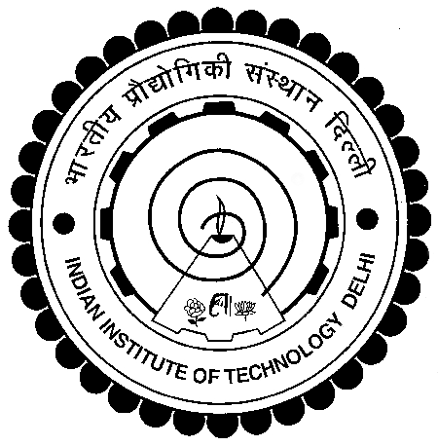

Proposed e-ITEC/ITEC Course 2022-23
Emerging Contaminants and Water Reuse
PART A
(Synopsis, Aim, Objectives, Outcomes, Audience, Eligibility)

a. Course Synopsis:
Recent years have seen increased reporting of emerging water contaminants, such as nanoparticles, heavy metals, antibiotic resistant pathogens, novel viruses (e.g., H1N1 influenza, SARS). Due to increased stress on water, efforts are underway to use wastewater effluent also for irrigation purposes. This effort may also pose effect of these emerging contaminants on soil, aquatic environment and also on human health if some inadvertent expose happens. The proposed course aims to train students, teachers, scientists, engineers and administrators to in understanding about types of emerging contaminants, their fate in aquatic and soil environment and their uptake by plants during practice of wastewater irrigation.

b. Aims of the Course:
The aim of this course to provide expertise to public, engineers, scientists and administrators about emerging water contaminants, their interaction with aquatic and soil environment and implication on soil, plants and human health during reuse of wastewater effluent as irrigation water. This course can help them in linking presence of emerging water contaminants to their effects on soil, water environment and also on human and environmental health.

c. Course Objectives / Learning Objectives:
The primary objectives of the course are as follows:
- to teach about emerging water contaminants –detection and fate in environment
- to teach the removal of emerging water contaminants from water treatment plants
- to teach fundamentals of interaction of emerging water contaminants with soil components and aquatic constituents
- to teach fundamentals of interaction of emerging water contaminants with plants
- to evaluate feasibility of using wastewater effluent for growing plants without affecting soil and human health on a long-term basis using case study based problems (group of 4-5 participants)

d. Course Outline (24hours)
Module no | Content | Date and duration
Module 1(6 hours) | Emerging water contaminants-detection and occurrence | Aug 8th, -Aug 10th , 2022
Module 2 (6 hours) | Fate in the aquatic system and soil system; uptake by plants | Aug 11th-Aug 13th, 2022
Module 3 (6hours) | Removal of emerging water contaminants in water treatment plants | Aug 14th-Aug 16th, 2022
Module 4(6hours) | Feasibility of wastewater effluent reuse and management needs; case study presentation | Aug 17th-Aug 19th 2022

e. Expected Course Outcomes of the Course:
The participants will be able to
- Identify emerging contaminants, fate and occurrence
- Evaluate the effect on soil, plant growth and aquatic constituents
- Estimate removal in water treatment plants for making the water suitable for irrigation purposes

f. Target Audience:
- Executives, engineers and researchers from the environmental engineering profession, service and government organizations including R&D laboratories.
- Student students at all levels or Faculty from reputed academic institutions and technical institutions.

g. Eligibility of the participants:
Applicants for this course must
- Graduates from across the spectrum of disciplines
- Engineers/Teachers / Trainers and/or Administrators in Technical and Vocational Education and companies
- Junior to Senior Level Government officials, Professionals and Academicians
- Proficiency in spoken and written English

h. Minimum and Maximum Participants: (10-50 participants)

i. Platform to be used for the online classes (in case of the e-ITEC programme) (MSteams or Zoom)

j. Evaluation Criteria
Online Quizzes; Open-ended Questions/Essays; Online Polls; End of Course Presentation

PART C
Co-ordinator Contact Details

Course Coordinator: Prof. Arun Kumar
Co-coordinator: Prof. Arya V.

Department/Centre/School: Civil Engineering, IIT Delhi
Web link: https://web.iitd.ac.in/~arunku/
Email: arunku@civil.iitd.ac.in
Mob: 91-8527843076

