HACCP AND ISO 22000 FOR FISH PROCESSING ESTABLISHMENTS

Date: January 09–21, 2023
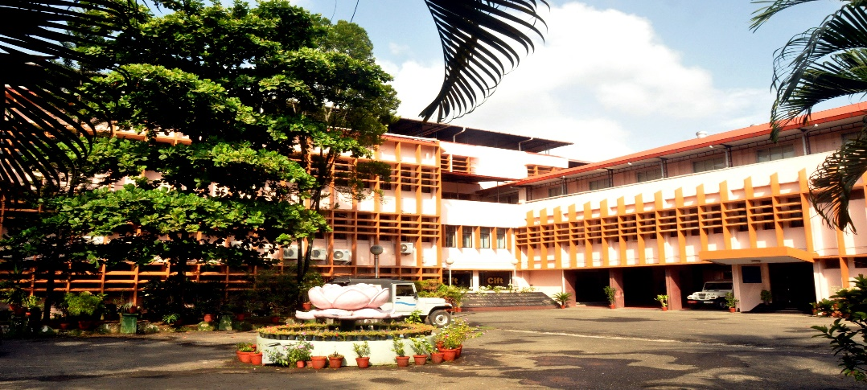

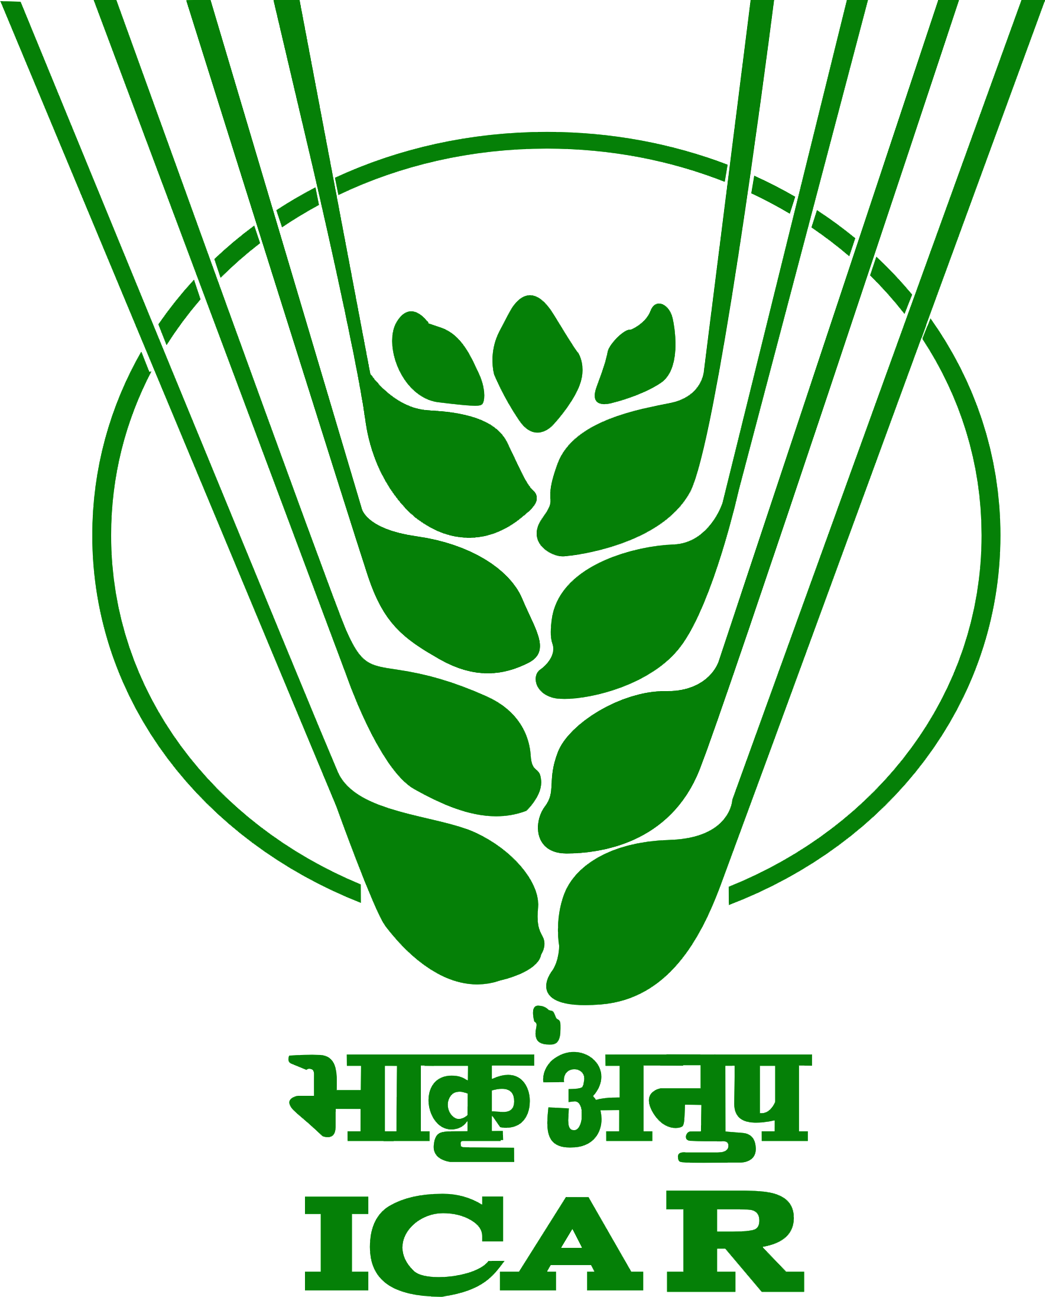
ICAR - Central Institute of Fisheries Technology
(ISO/IEC 17025 :2005 Accredited & ISO 9001 :2015 Certified)
CIFT Junction, Matsyapuri P.O., Kochi - 682 029, Kerala
Ph: 091-0484-2412300, Fax: 091-484-2668212, E-mail: cift@ciftmail.org, directorcift@gmail.com
URL: www.cift.res.in.
ICAR - Central Institute Of Fisheries Technology
(ISO/IEC 17025 :2005 Accredited & ISO 9001 :2008 Certified)
CIFT Junction, Matsyapuri P.O., Kochi - 682 029, Kerala
Ph: 091-0484-2412300, Fax: 091-484-2668212, E-mail: director.cift@icar.gov.in, directorcift@gmail.com

director.cift@icar.gov.in
directorcift@gmail.com
Fax: 091-484-2668212
ICAR - Central Institute Of Fisheries Technology
(ISO/IEC 17025 :2005 Accredited & ISO 9001 :2008 Certified)
CIFT Junction, Matsyapuri P.O., Kochi - 682 029, Kerala
Ph: 091-0484-2412300, Fax: 091-484-2668212, E-mail: director.cift@icar.gov.in, directorcift@gmail.com

director.cift@icar.gov.in
directorcift@gmail.com
Fax: 091-484-2668212
ICAR- Central Institute of Fisheries Technology
ICAR-Central Institute of Fisheries Technology (CIFT), a pioneer research institute under the aegis of Indian Council of Agricultural Research (ICAR) has been playing a pivotal role in pursuing its research and extension activities in harvesting and post harvesting sectors in fisheries during its fruitful existence since last six decades. Since its inception during 29th April, 1957; the institute has been instrumental in modernizing the fishing and fish processing sectors in the country and continues to impart technological support to a broad spectrum of stakeholders comprising of fisher folk, students, extension professionals, seafood industries, fish entrepreneurs, faculties and scientists through well designed skill-oriented training programmes. The major activities of the institute centers around evolving innovative and cost effective technologies for fish harvesting, development and standardization of different post- harvest practices, techniques for extraction of biomedical, pharmaceutical and industrial product from aquatic organisms, biotechnological approaches for disease diagnostic tools; quality management and maintaining food safety standards; design and development of tools and techniques for harvesting and storage and at the end transferring the technologies to end users through training, education and extension programmes with the involvement of highly qualified and experienced faculty scientists from seven different divisions viz., Fishing Technology, Fish Processing, Quality Assurance and Management, Microbiology, Fermentation and Biotechnology, Engineering and Extension, Information and Statistics Division.

Background of the course
Fish and Fishery products are highly perishable and easily spoil after harvesting due to postmortem chemical, physical and microbiological changes. These degradation processes are accompanied by the gradual loss or development of different off flavor compounds that affect intrinsic quality of the fish. Preservation of freshness quality of the fish by employing appropriate preservation techniques has been a challenging task. Anthropogenic impacts on fish habitats, un-sanitary post-harvest handling practices and global out-sourcing of food additives also results in un-intentional introduction of chemical and microbiological food safety hazards in seafood. Seafood being a globally traded commodity, enhancement of food safety principles has enormous implications, leading to higher consumer trust and greater economic returns.
Various seafood quality assurance programmes are in vogue across the world. Since introduction by NASA, Hazard Analysis and Critical Control Point system (HACCP) has been the most sought-after quality assurance approach across the world. The HACCP system involves the identification of specific hazards throughout the process involved in the production of a food product and focuses on the preventative measures for their control to assure the safety of the food. After adoption by Codex Alimentarius Commission (CAC/RCP 1-1969, Rev 3, 1997), many countries have introduced HACCP through national legislations. Seafood HACCP regulations (21 CFR Part 123) by USFDA has been effectively adopted across the world. EU food Hygiene regulations that came into force in 2006, apply effective and proportionate controls throughout the food chain, from primary production to sale or supply to the final consumer (from 'farm to fork'). The three basic EU food hygiene regulations are: Regulation (EC) 852/2004 on the hygiene of foodstuffs; Regulation (EC) 853/2004 laying down specific hygiene rules for food of animal origin and Regulation (EC) 854/2004 laying down specific rules for the organization of official controls on products of animal origin intended for human consumption. These regulations place primary responsibility of food business operators to produce safe food. Apart from these mandatory legislations, seafood industry has seen a great upheaval through food certification systems propagated by ISO (ISO22000:2018), FSSC 22000, British Retail Consortium (BRC), Safe Quality Food (SQF), IFS (International Food Standard) and benchmarking of food standards by Global Food Safety Initiative (GFSI).
Quality issues related to seafood sector have been diverse, which include progressive changes associated with loss in freshness quality as well as those introduced by poor post-harvest handling practices. The much discussed about issue is presence of biological hazards, which includes human pathogenic bacteria and their toxins. Fish and fishery products are known vectors for disease causing pathogens like Vibrio cholerae, Salmonella, Vibrio parahaemolyticus, Listeria monocytogenes, Staphylococcus aureus and Clostridium botulinum. Like other food sectors, seafood industry is not immune to emergence of new pathogens, which are becoming inherently unpredictable. As value-added seafood products incorporating plant based ingredients or other animal meat are not uncommon across ASEAN countries, seafood mediated transmission of emerging pathogens like Escherichia coli O157:H7 and Campylobacter jejuni cannot be ignored. Further, it requires a national surveillance network to source-track pathogens and devise suitable control measures. The other noteworthy quality problems associated with seafood are bioaccumulation of Cadmium in cephalopods, presence of norovirus in bivalves and histamine poisoning in tuna, mahi mahi and other scombroids.
Problem of residues of antibiotic and other prohibited pharmacologically active substances in cultured shrimp has been a major issue for India and ASEAN countries. To combat this problem, India has so far upgraded its seafood testing infrastructure as per international standards along with a validated residue monitoring plan. Lack of analytical skill and knowledge for detection of antibiotic residues, dioxins and unauthorized substances at stipulated minimum required performance limits (MRPL) as required by European Council Directive 220/657/EC has been a major problem for many developing nations.
The training on various aspects of seafood quality assurance including advanced detection methods for veterinary drug residues, pesticides and polyaromatic hydrocarbons, simultaneous determination of heavy metals, rapid detection of pathogens and bacterial toxins and sensory evaluation techniques will be significant. Further, aspects of laboratory accreditation, validation of test methods, performance of analytical methods and interpretation results as per EU guidelines shall also be covered.
There has been wide-spread initiative by the policy makers across nations to leap-frog their country status in line with developed countries in terms of establishing a strong food safety framework. The major bottleneck has been absence of trained adequate manpower to understand and implement modern food safety principles. As far as CIFT is concerned, this institute has played a pioneering role in advancing the seafood quality assurance regime in India from consignment-wise inspection system to fully HACCP-compliant enterprises. The scientific manpower of CIFT is fully equipped in carrying out food safety audits as per national and international standards. In the recent past CIFT has hosted international training programmes in seafood quality assurance, ISO 22000:2018 and HACCP audit for officials, industry representative and academicians from countries like Bangladesh, Sri Lanka, Philippines and Myanmar.
Broad outlines of course
The training program on HACCP and ISO 22000 for Fish Processing Establishments systematically introduces ISO 22000 with the overview and basic concepts required for understanding. The HACCP principles, preparation of HACCP manual, conducting hazard analysis, formation of HACCP plan form, development of prerequisites for safe food preparation etc., so as to enable the trainees to prepare a manual, prepare HACCP plan and conduct verification/ audit on their own. The trainees will be familiarized with all types of hazards viz., biological, chemical and physical, commonly encountered in the seafood industry. The course covers the following contents:
• International regulations in seafood safety
• Overview of ISO 22000 FSMS
• Key elements and Scope of FSMS
• Familiarization with terminologies of FSMS
• Designing food safety management system
• Management of resources in implantation of FSMS
• Hazards in fish and fishery products
• Planning and realization of safe products-PRP, OPRP and CCP;
• Verification planning and traceability systems in FSMS
• Process of certification and accreditation in FSMS
• FSMS audit
• Validation and verification of FSMS
• Control of non-conformities in FSMS

